LANDMARK DESIGNATION REPORT
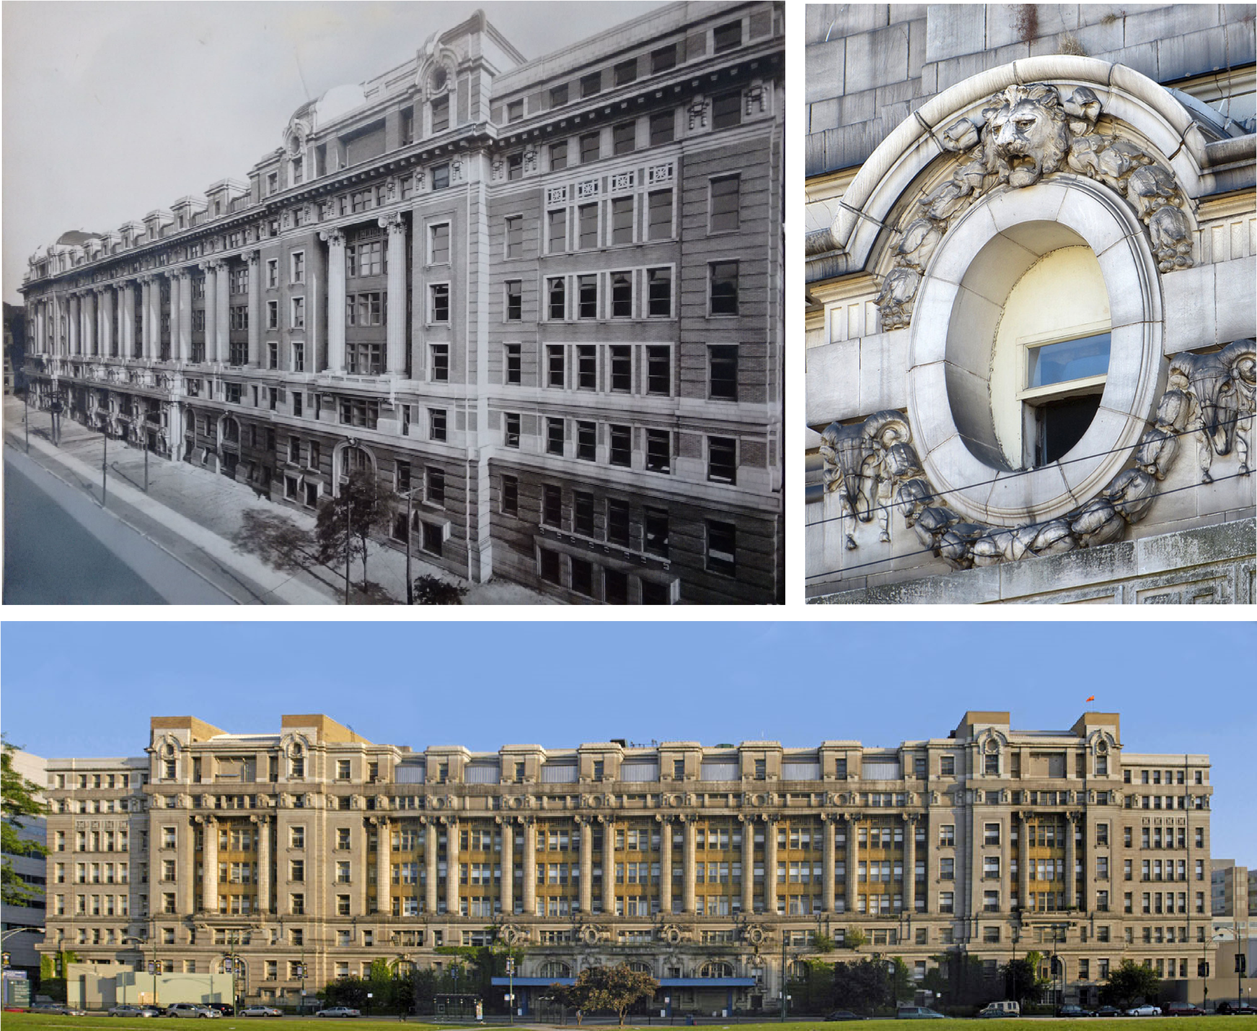

Cook County Hospital Administration Building
1835 W H S

Final Landmark Recommendation adopted by the Commission on Chicago Landmarks, November 1, 2018

CITY OF CHICAGO Rahm Emanuel, Mayor

Department of Planning and Development David Reifman, Commissioner

T C

Introduction 3

Map 5

The Establishment of a Cook County Hospital and its Early Buildings 3

The Construction and Description of the Cook County Hospital Administration Building 7

The Classical Revival Style and the Influence of the Ecole des Beaux-Arts on the Cook County Hospital Administration Building 15

Architect Paul Gerhardt, Sr. 18

Medical History and Advances at Cook County Hospital 19

Criteria for Designation 27

Significant Historical and Architectural Features 31

Selected Bibliography 31

Acknowledgements 33

Cover photographs from (clockwise from top left)
“The Man on Five” website - http://themanonfive.com/page/59); “Curbed Chicago” website (https:// chicago.curbed.com/2014/9/24/10043556/fate-of-old-cook-county-hospital-to-be-decided-in-comingweeks) (top two photos); and “Dresden Files” website - http://dresdenfiles.wikia.com/wiki/ Cook_County_Hospital

C C H A B

1835 W H S B : 1912-1914

A : P G , S .

The Cook County Hospital Administration Building is one of Chicago's grandest public buildings and exemplifies the importance of local Cook County government in the care and welfare of its citizens. It represents the historic commitment of Cook County to provide medical care to its citizens regardless of their ability to pay. Over its almost 90 years of service, the Administration Building served Cook County's indigent and under-served populations, including immigrants and African Americans. Cook County Hospital, throughout the history of the institution, saw significant medical advances, including the United States' first blood bank, the identification of the cause of sickle-cell anemia, and the innovation of a professional medical internship program.

The Administration Building is a significant Classical Revival-style public building that exemplifies the influence of the Ecole des Beaux-Arts and its design traditions on American architecture of the 19th and early 20th centuries. Its symmetry and balance, the arrangement of its exterior forms, and its use of Classical-style ornamentation place it in the Parisian design school's traditions, and it is one of the best such buildings in Chicago. Located on the northern edge of the Illinois Medical District (IMD) on Chicago's Near West Side, the Cook County Hospital Administration Building is a visual "gateway" to the IMD today, clearly visible to thousands of commuters each day traveling by car on the nearby Eisenhower Expressway or by Chicago Transit Authority Blue Line rapid transit.

T E C C H E B

Cook County was established in 1831, with Chicago following in 1833. Life on the prairie was crude and rough. But counties at that time, and continuing to the present day, were responsible for health care for indigent residents. Cook County was no exception.

Early on, such medical care in Cook County was spotty and catch-as-catch-can. Poor people who needed hospitalization were cared for through a variety of places, including Chicago's poorhouse, private homes, and Tippecanoe Hall, a building just north of the Chicago River at State and Kinzie streets. Cook County provided medical supplies, but doctors provided unpaid time for the care of the indigent. A private hospital, the Illinois General Hospital of the Lakes, was established with just 11 beds at North Water and Rush streets by Rush Medical School doctors in 1850, and it took in patients sent by Cook County, but with the clear direction that treatment be "at the 'lowest possible expense'," as noted in John G. Raffensperger's The Old Lady on Harrison Street: Cook County Hospital, 1833-1995.

This facility would, within a few years, be transferred to the charge of the Sisters of Mercy, a Catholic order dedicated to medical care, and be renamed Mercy Hospital. The order moved the newly-named hospital back to Tippecanoe Hall in 1853, and for the next ten years, Cook County provided the Sisters of Mercy three dollars per patient per week to care for sick and destitute residents.

However, Cook County's farming-out of health care was already seen, by the 1850s, as an inadequate response to the medical needs of its citizens. Cholera epidemics that swept through Chicago in 1849 and 1854 were wake-up calls that the community needed a public hospital. A temporary hospital set up by the City of Chicago during the 1854 epidemic led to a permanent hospital in 1857 known as City Hospital. Designed by architects Carter and Bauer, this building stood at 18th Street and Wentworth Avenue (at the time known as Arnold Street). It was three stories high, built of red brick above a basement of Lemont limestone, and cost $75,000.

Unfortunately, City Hospital, as it was known, sat empty for two years because Chicago city government failed to spend the money to properly outfit it with furniture and medical equipment. In 1859, doctors associated with Rush Medical College leased the building for use as a training hospital for medical students. During the Civil War, in 1862, the federal government took over the building and ran it as a military hospital. The building was closed at the end of the war in 1865.

Advocacy efforts by several Chicago doctors, including George K. Amerman and Joseph P. Ross, led to Cook County's acquisition of the former City Hospital building. On January 1, 1866, the building reopened as the first Cook County Hospital. It housed 130 beds, which soon proved inadequate, but the building had good ventilation and lighting, as well as steam heat, and it was a distinct improvement over the out-sourcing of medical care that had occurred in Cook County during the previous 30 years. The major problem facing indigent health care in Chicago was not the building, but graft and corruption at the County level, sapping available funds for medical care itself.

Sadly, the Cook County Hospital building began to deteriorate. Sanitation was inadequate, resulting in roaches and rats. Overcrowding was temporarily alleviated by the construction in 1870 of a new three-story south wing which increased beds to 220. The building was outside the burn zone of the Chicago Fire of 1871 and served many fire victims. Sadly, facility overcrowding again became a constant blight on care. This led to the Cook County Board building a new hospital facility, and it led to Cook County Hospital as an institution being moved to Chicago's West Side.

In early 1874, the County Board preliminarily selected a 12-acre site owned by a "Mr. Baldwin" as the location for the new hospital. These so-called "Baldwin Blocks" were located west of Ashland Avenue and were bounded by Harrison, Polk, Wood, and Lincoln (now Wolcott) streets. This part of the West Side was relatively under-developed and seemed well suited for the new hospital.

Then, indecision on the part of the Board led first to a decision to purchase a different site, then a return to the original Harrison Street location. This vacillation may have been in response to political pressure from nearby property owners who objected to the institution's relocation to the Harrison site, fearing decreased property values. Regardless, the Cook County Board voted to
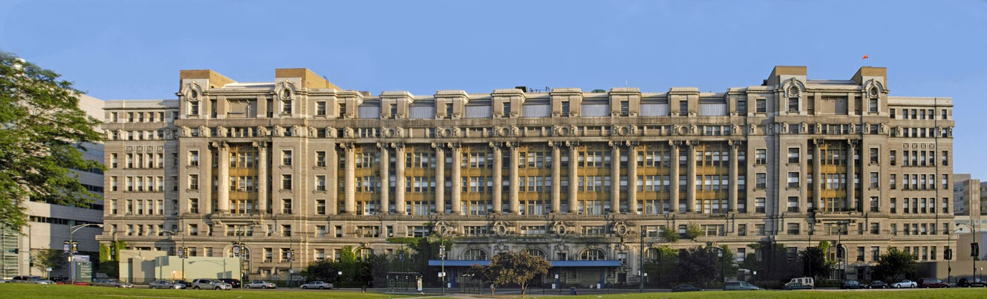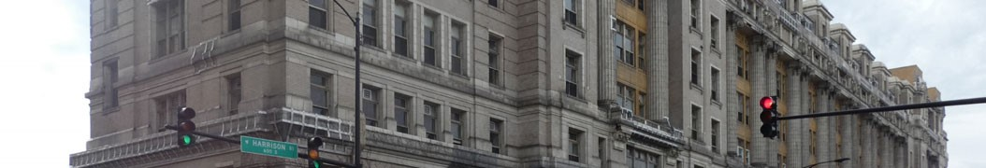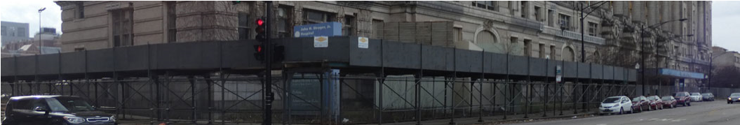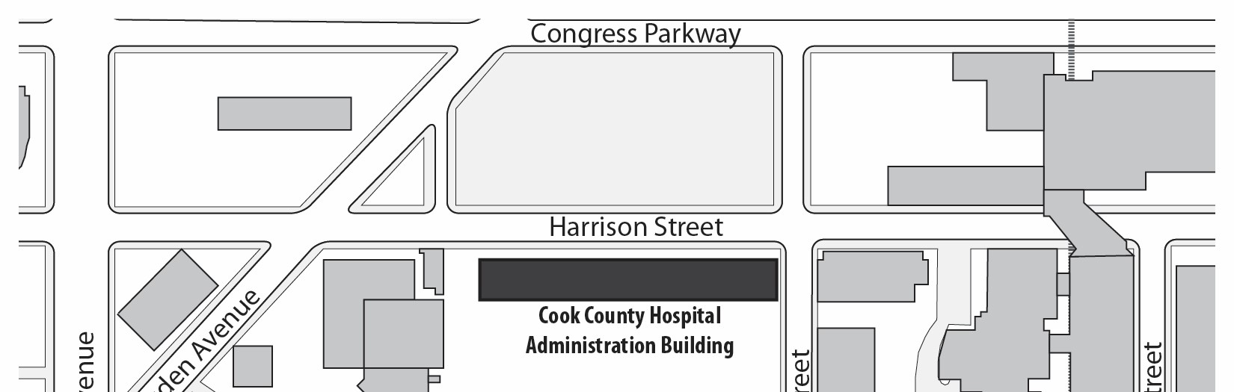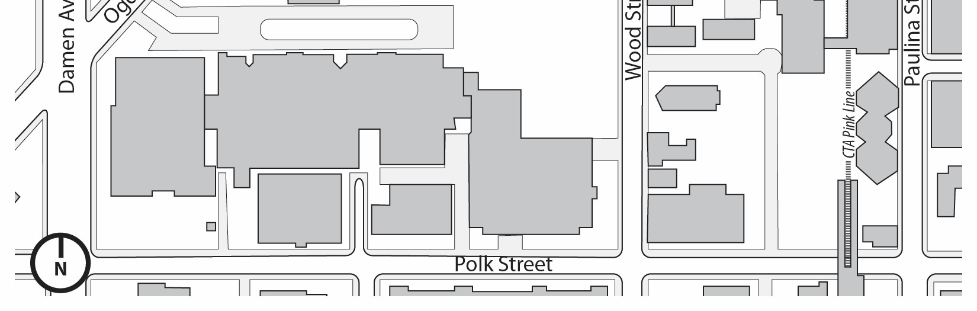
The Cook County Hospital Administration
Building is located on Chicago’s Near West
Side at the northern edge of the Illinois
Medical Center. Built between 1912 and 1914,
it is a massively-scaled building, eight stories
in height, that stretches for a full city block
opposite Pasteur Park.

The building is designed in the Classical
Revival architectural style with design
influences from the Ecole des Beaux-Arts, the
world’s leading architectural school at the
time of its construction.

Photographs:
Top from “Dresden Files” website - http://
dresdenfiles.wikia.com/wiki/
Cook_County_Hospital
Bottom courtesy MacRostie Historic Advisors
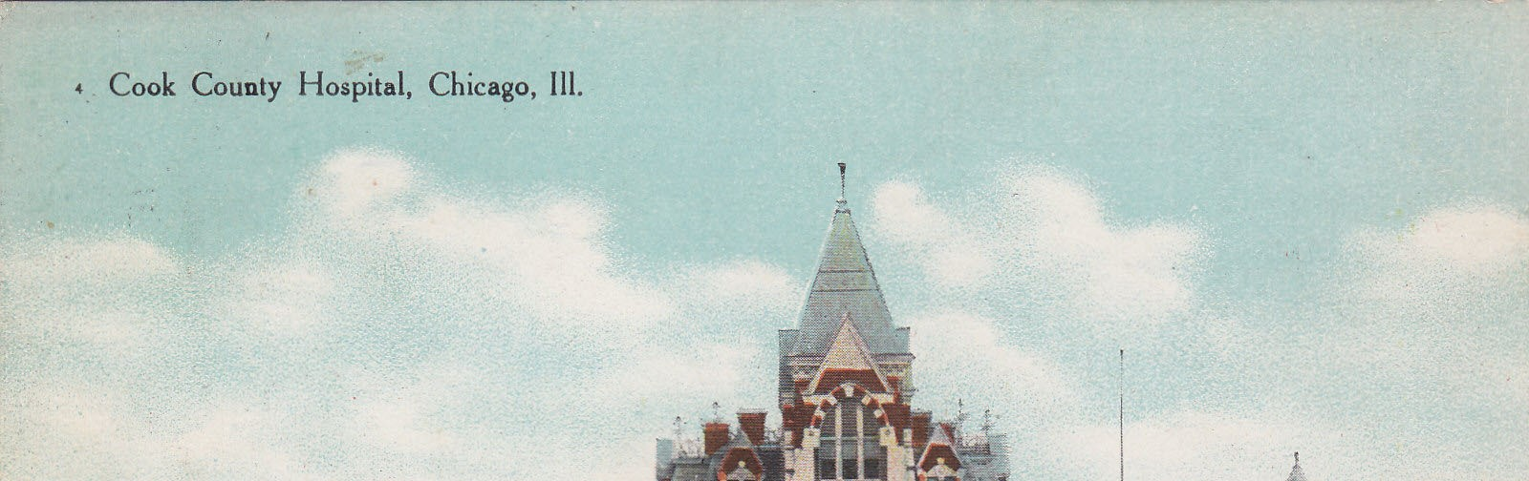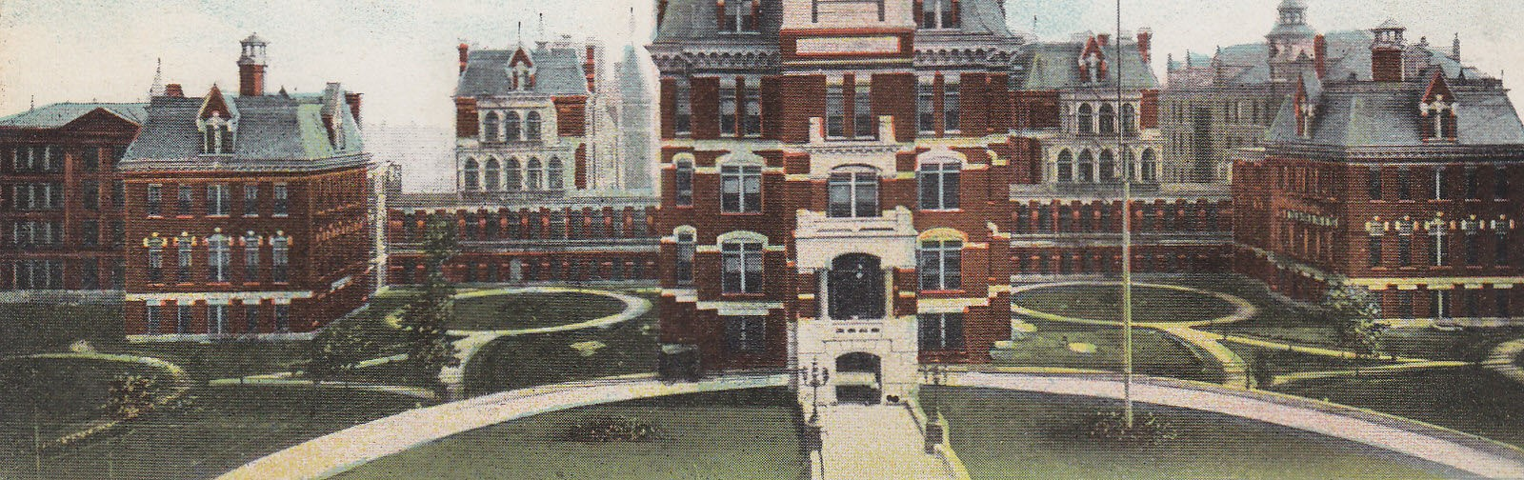
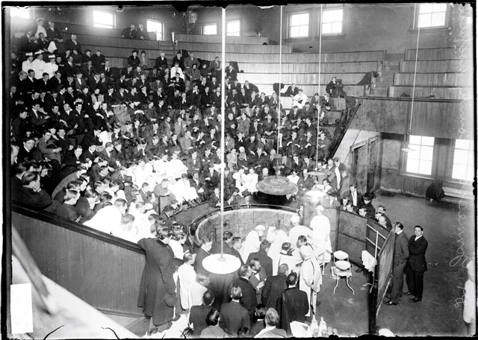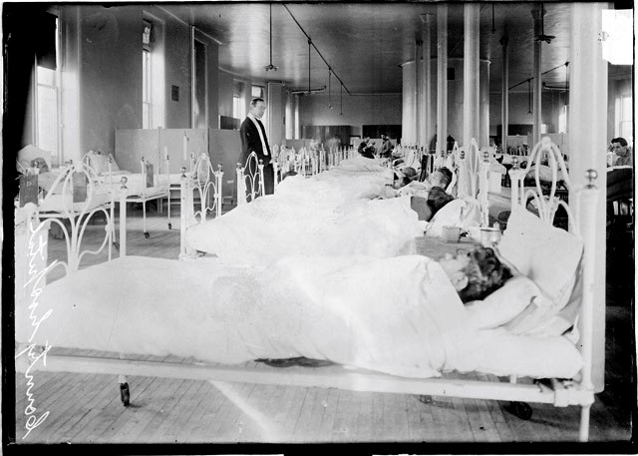
The predecessor Cook County Hospital was built during a roughly 10-year period from 1874 to 1884, and served as the County’s hospital until the Cook County Hospital Administration Building was built in the 1910s. Designed by architect John C. Cochrane, the predecessor hospital was built in the Victorian Gothic architectural style using contrasting red brick and light stone.

Top: A postcard view of the predecessor hospital (from “Moore’s Postcard Museum” website - https://postcardmuseum.wordpress.com/page/60/

Bottom left and right: Interior views of the predecessor hospital, including male patients in a dormitory ward and Dr. Thomas Johnmesco performing an operation (from Chicago Daily News collection, Chicago History Museum.
buy the Baldwin-owned parcel in May 1874. By that point, the original $130,000 asking price for the land had increased to $145,000.

The new 300-bed Cook County Hospital was designed by architect John C. Cochrane. Cochrane is best known today for his designs for the current Illinois State Capitol building in Springfield and two designated Chicago Landmarks, All Saints Episcopal Church at 4550 N. Hermitage Ave. (built 1883) and the Wood-Maxey-Boyd House at 2801 S. Prairie Ave. (built 1885). The new hospital opened in 1876. It was built with red-brick walls in the Victorian Gothic architectural style and was laid out with a central building flanked by almost free-standing pavilions. This type of building layout was increasingly advocated by hospital designers and administrators for providing maximum light and air to patient wards and treatment areas.

The hospital was built in stages. Two pavilions, a boiler house and laundry facility, kitchen and mortuary were completed first in 1876, and patients were moved from the old 18th and Wentworth facility in October 1876. The next year, a clinical amphitheater was completed. The hospital's imposing, high-roofed administration building was completed in 1883-1884, along with two additional pavilions. The final cost of the hospital complex was reported as $719,574, including land, buildings, and equipment.

The design of the new Cook County Hospital was considered modern for the day. Author John G. Raffensperger, in his history of Cook County Hospital, discussed the layout:

The pavilion system consisted of fourteen wards, each housing patients in a large room. In addition, there were two wards for erysipelas patients, a common skin infection due to streptococcus. There were three male and one female medical wards, and five male and two female surgical wards. In addition, there was one ward each for obstetrics and children. Each ward had its own kitchen, dining room, nurses room, operating room, bathroom, isolation rooms, and linen closet. The wards either held thirty patients or fifty patients, and were ventilated with a large cylindrical air shaft from the floor to the roof in the center of the room . . . The [central hospital] kitchen had a fourteen foot long range and broiler, as well as urns and boilers for the preparation of hot beverages. It was described [in publications of the day] as one of the best planned hospitals in the United States.

The administration building held offices, storage rooms for drugs, apartments for hospital staff, and dining facilities. The clinical amphitheater held 600 people and was used for church services on Sunday as well as teaching. This iteration of Cook County Hospital was expanded over time, with additional pavilions and associated buildings built in 1897, 1903, and 1908-1909. With the construction of the last addition in 1909, the facility had an impressive 2000 beds for patients.

Unfortunately, the hospital continued to suffer from ills associated with the earlier facility at 18th and Wentworth, including chronic underfunding, unsanitary conditions, and poor food, all made worse through political interference. Some of the political problems were eased in 1905 when civil service standards reformed how doctors got their appointments to the hospital. Up until then, under -the-table payments to Cook County commissioners by doctors seeking hospital privileges were not uncommon.

T | C |  |  | D
C | C | H |  | A |  | B

Although the 1870s-era Cook County Hospital was state of the art when built, advances in medical science and care, not to mention architectural construction techniques, made it obsolete by the early 1900s. In 1910, the Cook County Board established a commission to study hospital conditions.
Issued in September 1910, the commission's report noted the existing facility's "overcrowded" state and its "unsanitary condition." A three-million-dollar bond issue was urged to pay for construction of a fireproof, 3,500-bed replacement hospital.

In the early 1900s, Cook County had on staff a County Architect, at this time William Holabird of the noteworthy firm of Holabird & Roche. Holabird drew up a proposal for a new hospital that called for an expansive complex of five interconnected buildings clad with white glazed terra cotta and white glazed brick. Although voters approved the bond issue in the November 1910 election, they also replaced the existing Board president with another, Peter Bartzen, who promptly replaced Holabird with architect Paul Gerhardt, Sr. Holabird's plan was subsequently shelved.

The Cook County Board decided in February 1911 to spend one million of the approved bond issue to construct a new hospital administration building with two rear wings for hospital wards and patient care. Gerhardt drew up a scheme for such a hospital that was made public in June of that year. His original plan, subsequently modified, was for a ten-story administration building extending for 600 feet along West Harrison Street. Two 200-foot-long, ten-story rear wings would extend to the south. By early 1912, this proposed building had shrunk in height to eight stories and been reduced in length. The original two rear wings were to be joined by two additional wings. In addition, the building was to be largely clad with brick with terra-cotta ornament.

It is unclear today, given lack of documentation, why this reduction in size occurred, although cost probably was a factor. Construction of the new Cook County Hospital was stalled in 1912 by construction bids that were greater than expected, plus political sniping about the professional qualifications and stature of Gerhardt himself, who seems to have been a polarizing figure. Previous work that he had done at the County's Oak Forest hospital had been controversial, and the Chicago Daily Tribune, in a February 17, 1912, editorial, sneered at the County Board for hiring a "mediocre" architect, rather than holding an open-juried design competition or employing an architect "with high standing or of special experience in construction of this nature." Later in the year, on May 23, the Chicago Record-Herald reported, "Paul Gerhardt's ambition to build a palacelike [sic] hospital that would make the county famous has been blamed for the complications which are threatening delays to the work."

These complications were further tainted by persistent rumors that Gerhardt himself stood to profit through financial connections with a company manufacturing a specific type of "sanitary" door frame specifically called out in his building specifications. The whispering campaign against Gerhardt, reported in the press, and the uncertainty over his specifications caused significant delays in getting an acceptable construction bid and the naming of a general contractor for the new hospital. Finally, on November 11, 1912, the Cook County Board selected the prominent construction firm of John Griffiths & Son, with their winning bid of $2,275,000.

A new election that month replaced County Board President Bartzen with Alexander McCormick.
Soon after taking office, McCormick fired Gerhardt and replaced him with Richard E. Schmidt. Schmidt finished the Cook County Administration Building largely as Gerhardt intended, although he revised the plans to remedy what were called "carelessly drawn" details by Board President McCormick. On March 8, 1913, the cornerstone of the new hospital building was laid in a ceremony witnessed by McCormick, other Board members, Schmidt, and several dignitaries.

Changes to plans for the Cook County Hospital Administration Building continued to be made during construction to deal with cost overruns and to improve the design. The new projected building cost of $3,490,610 was achieved partly by downscaling the building through the elimination of two of the four rear wings from the final building design. Cost increases and political infighting continued to dog construction into 1914, past the completion of the building's exterior in December 1913. Lack of money prevented the outfitting of the building's interior and the construction of rear wings and the building's power plant until 1914 and later. Although work continued on the building and additions for several years, the Cook County Administration Building as it exists today was finished in 1914.

Description
The Cook County Hospital Administration Building is located in the Near West Side community area of Chicago. It occupies a block-long portion of West Harrison Street between South Wood Street and the vacated right-of-way of South Wolcott Avenue. Located on the south side of Harrison, the building faces north onto Pasteur Park, a modestly-landscaped greensward. To the north, beyond Pasteur Park, is the Eisenhower Expressway (I-290) with its Chicago Transit Authority Blue Line. The Administration Building's location and visibility from the Expressway makes it a de-facto gateway building to the larger neighborhood.

The Administration Building is on the northern edge of the Illinois Medical Center, a large group of hospitals, classroom buildings, and other structures owned by a number of institutions, including Rush-Presbyterian-St. Luke's Hospital, the University of Illinois Hospital, the University of Illinois College of Medicine, and the Jesse Brown Veterans Affairs (VA) Hospital. The Administration Building's great scale is less noticeable among the many large medical buildings that comprise the Medical Center. To the southeast, the John H. Stroger, Jr., Hospital of Cook County, which replaced the older Cook County Hospital in 2002, is separated from the Administration Building by a surface parking lot and a vacant lot where the Fantus Clinic, a later addition to the Cook County Administration Building, once stood.

The Cook County Hospital Administration Building as it exists today has a long, rectangular footprint that is relatively narrow given its block-long length. It is eight stories in height. Its main street facades, facing north, east and west, are clad with pale tan brick and ornamented with white terra cotta. The building's base has a granite water table and a granite-look course of terra cotta. The great scale of the building is softened on these street facades through a tripartite division of two-story base, five-story shaft, and one-story top, similar to the traditional facade divisions found in early skyscrapers. The rear (south) facade, a secondary elevation throughout the building's history, is much plainer with tan brick walls and scarring from the removal of rear wings in the years since the building's closing in 2002. The building's windows are evenly placed in a grid-like pattern.

The Administration Building’s great scale and visually-rhythmic arrangement of Classical-style forms and details gives it the visual sense of a great Baroque-era palace or 19th-century European government building. From its opening, the building was meant to convey the importance of its function as Cook County's premier public medical institution through the impressiveness of its architecture.

The front (north) facade is the building's main elevation. It is symmetrical and balanced, and has a visually-rhythmic appearance, with the building's central and end sections, set back slightly, separated by mid sections extended forward. This visual "in-and-out" harkens back to the Baroque era of the 1600s, when European churches and palaces were often built in this manner.

The front facade has Classical-style ornament of various sorts, including pairs of "giant-order" columns that are three stories in height, cartouches, swags, decorative sills with brackets, window grilles, and moldings. Although the facade has an overall decorativeness, ornament is most concentrated around the building's main entrance, set in the center of the facade, within recesses that define floors four through six, above and around many windows and other building openings, and at the building's roofline, especially where the facade projects forward.

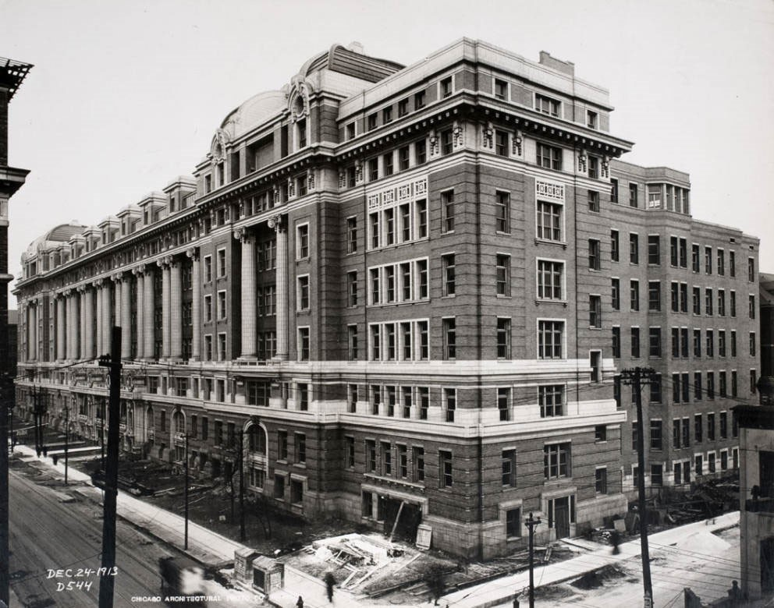
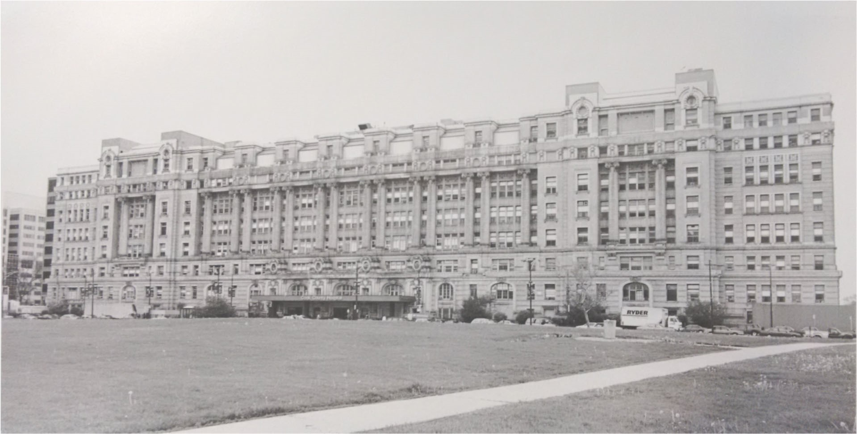
Historic photographs of the Cook County Hospital Administration Building.

Top: Photograph taken on December 24, 1913, before the building’s completion (from “The Man on Five” website - http://themanonfive.com/page/59)

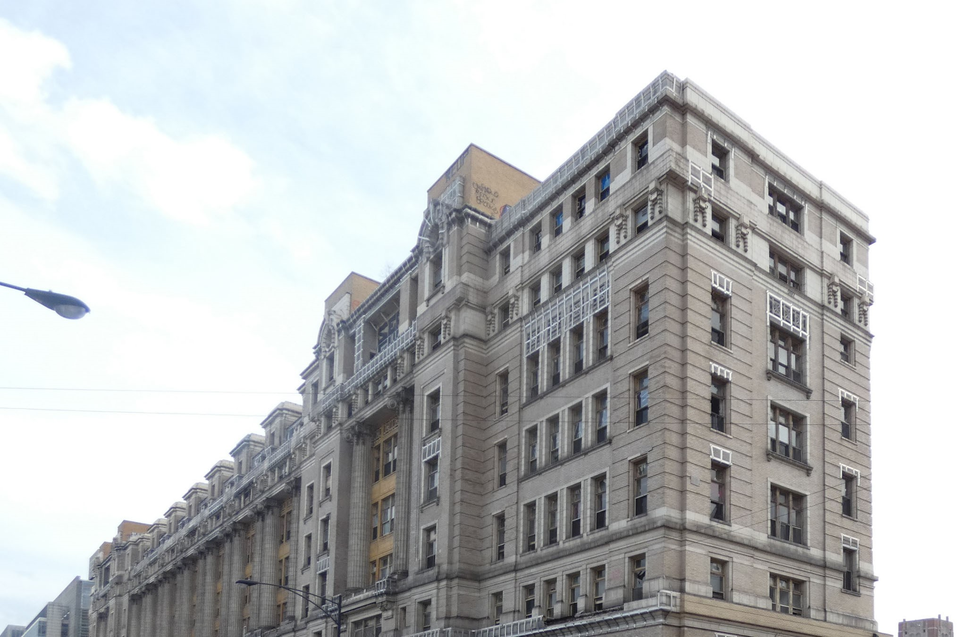
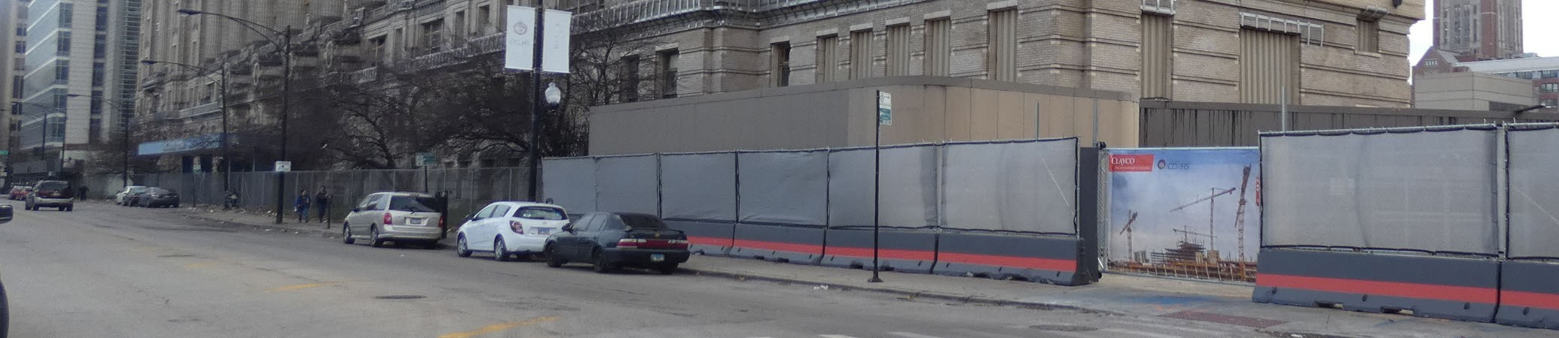
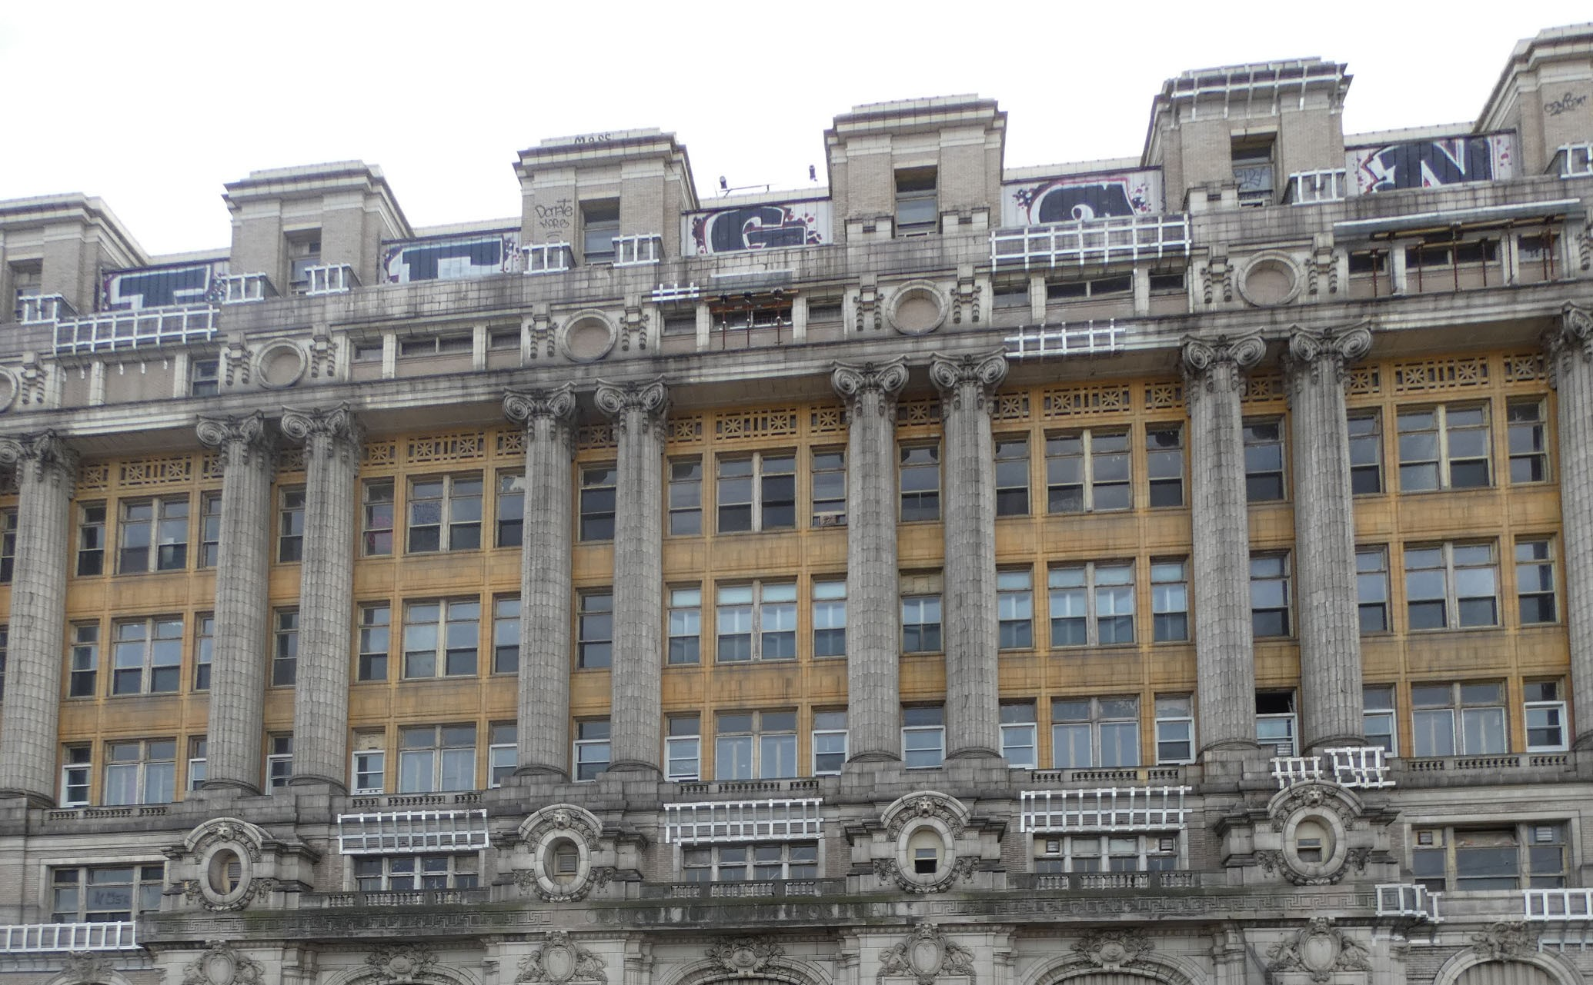
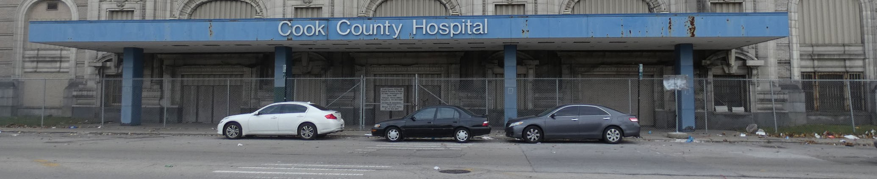
Bottom: Photograph circa 1990s (from Chicago History Museum prints and photographs collection) the Cook County
Current photographs of
Hospital
Administration
Building (courtesy
MacRostie Historic
Advisors)

Top: Photograph of
overall building,
looking southeast.

Bottom: Photograph of
south.
central section of building and main entrance, looking
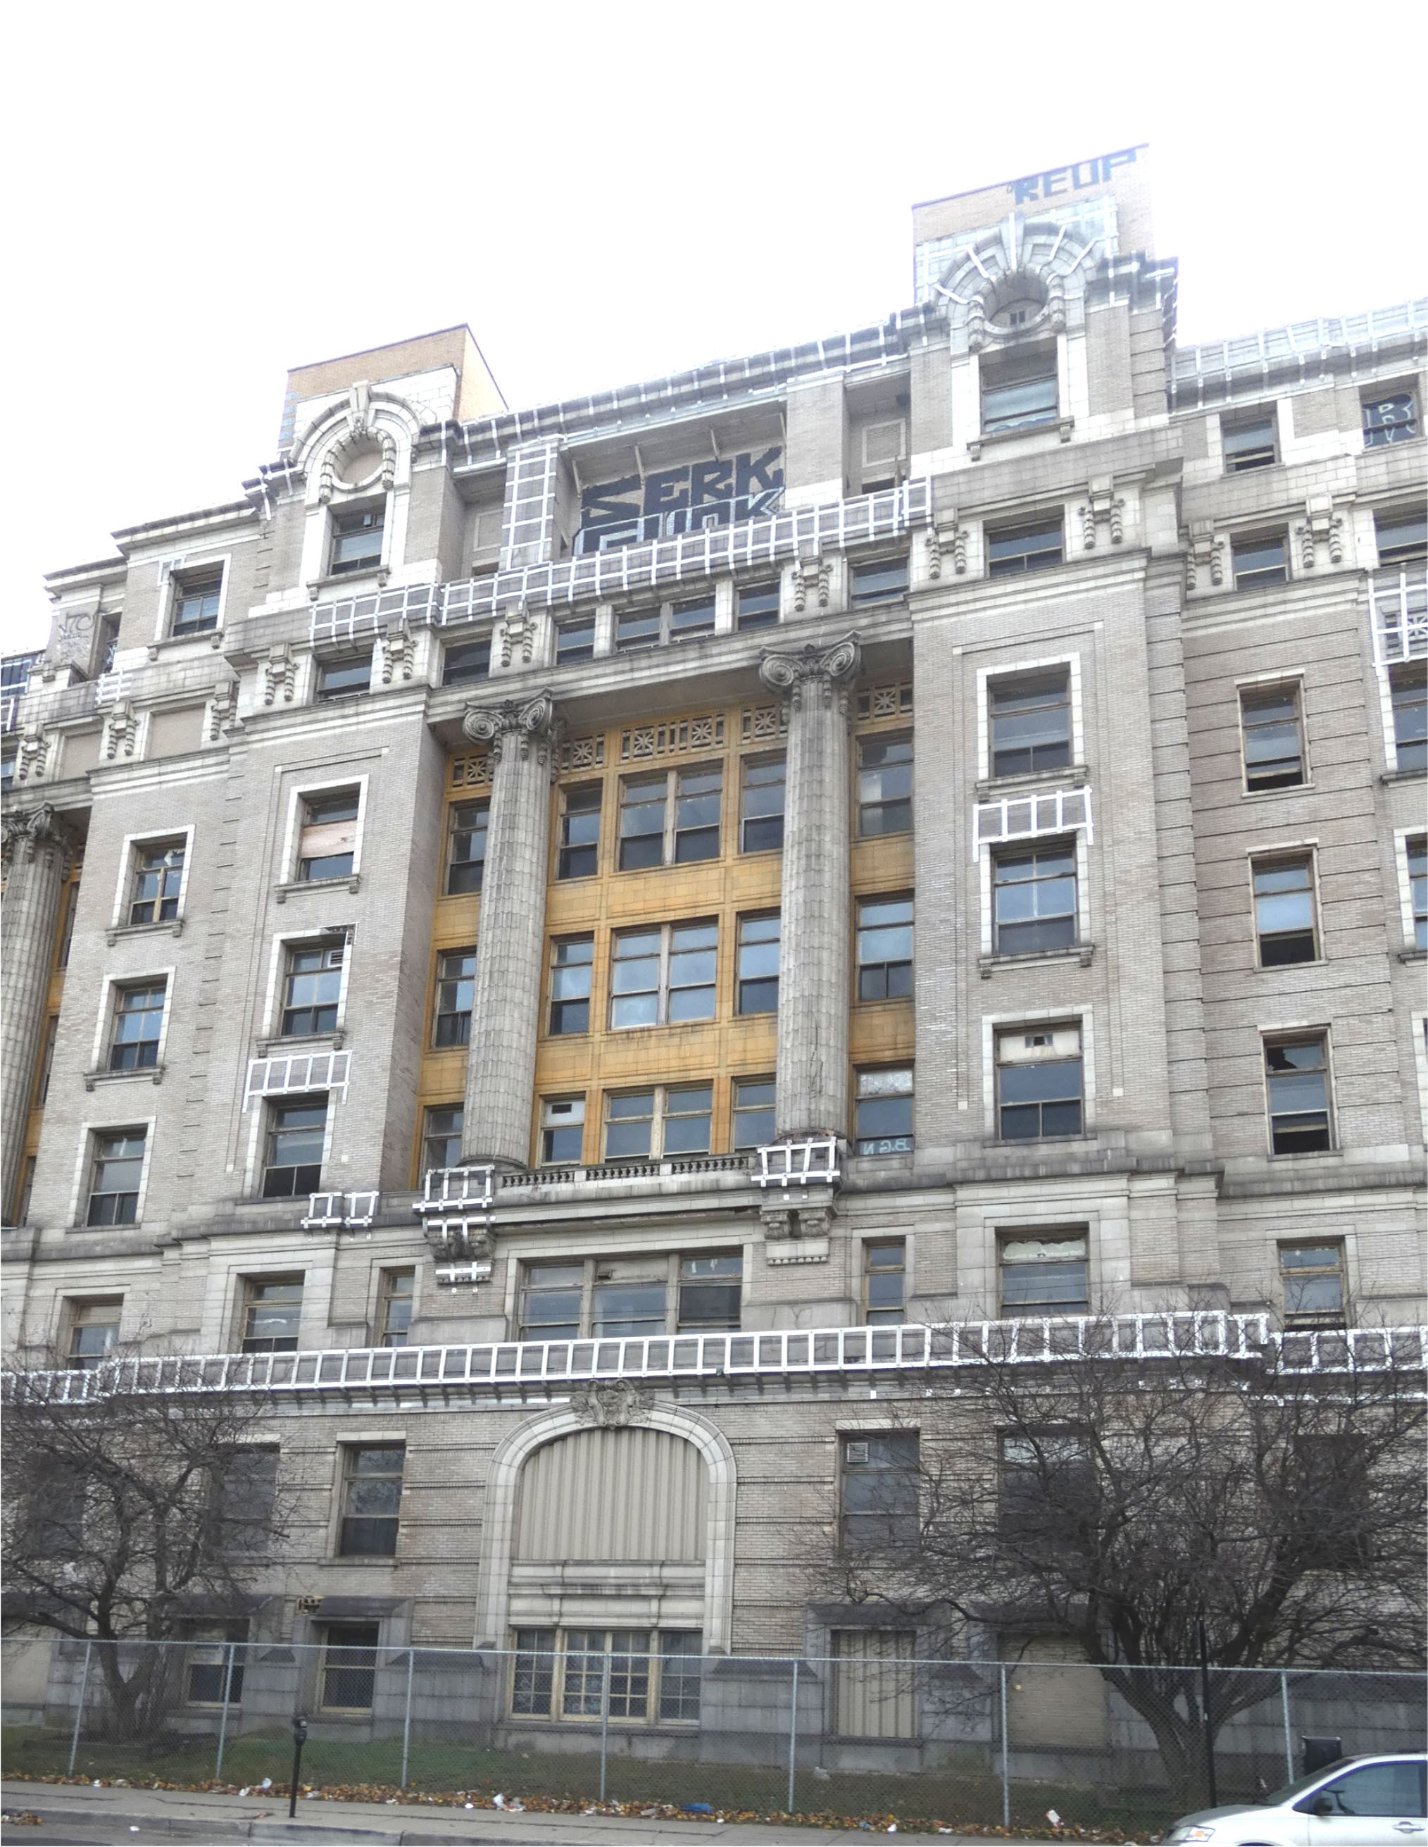
A photograph of a portion of the hospital’s front (north) façade (courtesy MacRostie Historic Advisors).
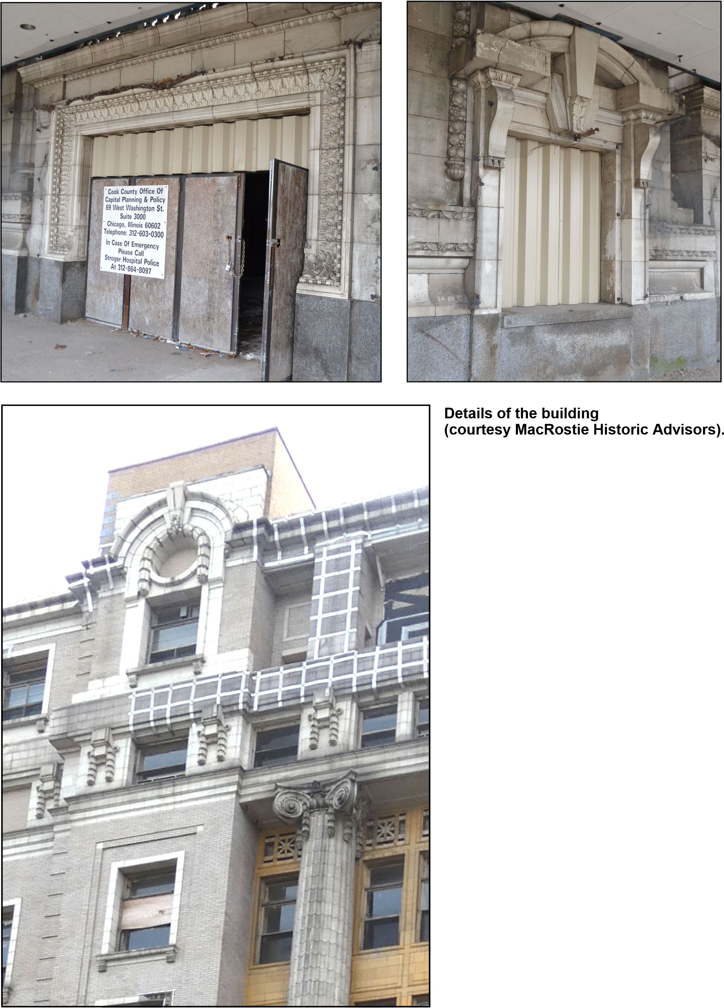
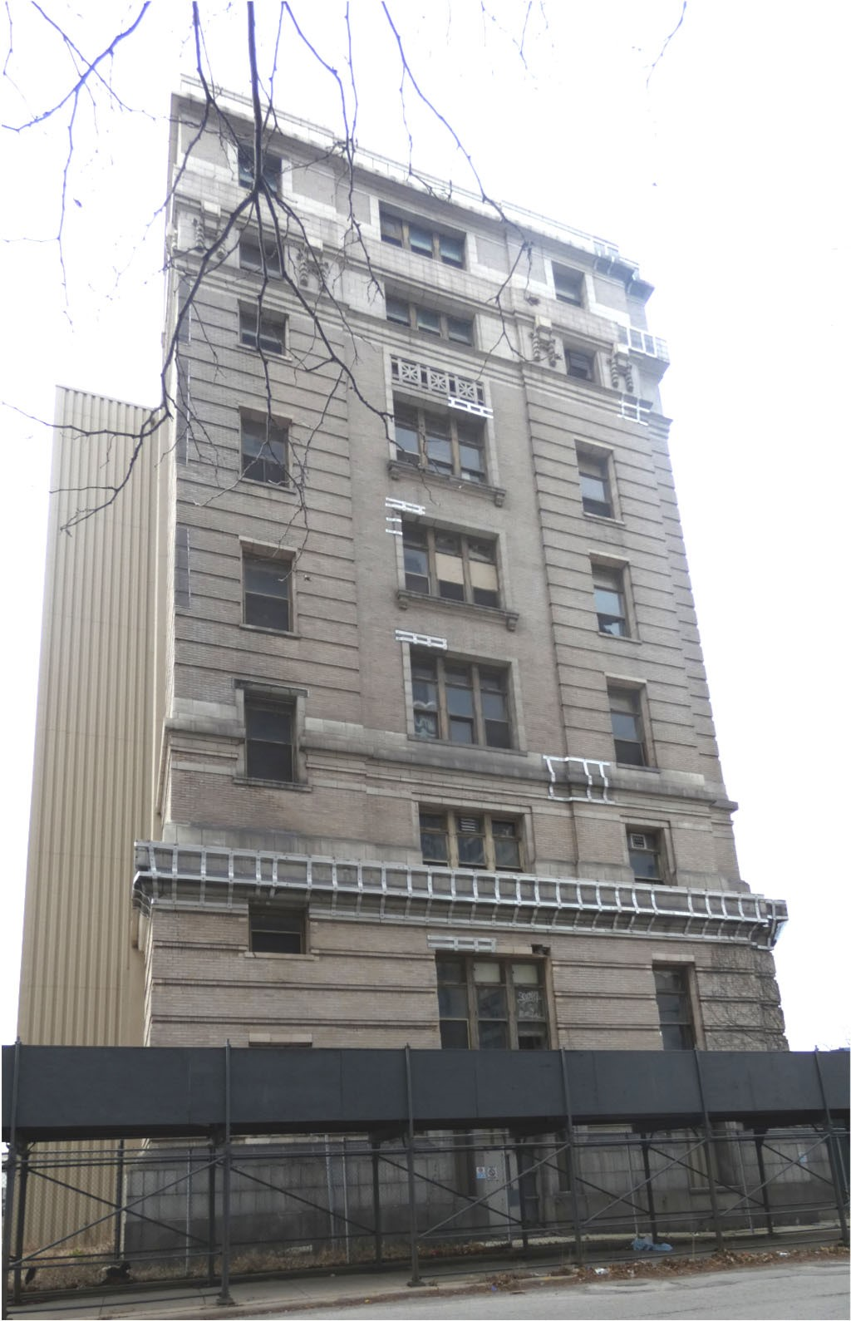
Right: A photograph of the east building
elevation, looking west.

Bottom: A photograph of the rear (south)
elevation, looking northwest.

Photographs courtesy MacRostie Historic
Advisors.
East and west elevations are similar to the front facade in their use of materials and ornamentation, but without the rhythmic in-and-out of their facades. As previously mentioned, the rear facade, always secondary, is quite plain.

T C R S I E B -A C C H A
B

The Cook County Hospital Administration Building is one of Chicago's most significant Classical Revival-style buildings in the Beaux-Arts tradition, truly a palace of medicine for the poor. Its large scale and symmetrical and rhythmic facades are characteristic of the Beaux-Arts design traditions. The Administration Building's use of the Classical Revival architectural style is also typical of Ecole teachings, which advocated this ancient and well-established architectural tradition for modern and spatially complex buildings. The building's appearance is consistent with how Americans in general, and Chicagoans in particular, saw public-building design in the 1910s. With a few exceptions, most Americans wanted buildings that were modern and up-to-date in function, but were designed using traditional architectural styles. In that context, the Classical Revival style remained an important part of American cultural life.

The Classical tradition in architecture and design is one of the oldest and most significant traditions in Western civilization, influential from its origins in the Greek city-states of the 6th century BC through the present day. The architecture of ancient Greek temples and sacred buildings was widely admired by other Mediterranean cultures, including ancient Rome, which incorporated Greek Classical architectural forms and details in its buildings throughout its empire.

The effort to keep Classical architecture as a living architecture was an important part of the Italian Renaissance, when architects sought to revive Classicism through a melding of ancient Roman Classical forms with contemporary building types, including palaces and churches. This effort to keep Classical architecture alive continued through the Baroque era of the 17th century, the Rococo and Neoclassical periods of the 18th and early 19th centuries, and the Greek Revival, Renaissance Revival and Classical Revival periods of the 19th and early 20th centuries. Classical design was seen as a significant aspect of Western civilization, and buildings intended to house important cultural, economic, or social institutions, whether public or private, often utilized Classical forms and ornament as part of their designs. By the early 1900s, the Classical Revival style was increasingly adapted to a wide variety of modern building types, including banks, university buildings, railroad stations, hotels and hospitals.

The Ecole des Beaux-Arts was a leading influence on the continued use of the Classical Revival style. Located in Paris, the Ecole was the world's leading design and architecture school in the 19th and early 20th centuries. Its design tenets focused on incorporating rational function and modern technology into large-scale, symmetrical and balanced building exteriors that typically utilized Classical forms and ornament. Beaux-Arts-influenced buildings often have visually-complex, monumental exteriors yet relatively uncomplicated plans. Beaux-Arts architectural practices were adopted by United States architecture schools and influenced several generations of American architects, including Gerhardt.

The Cook County Hospital Administration Building's large scale and its grandly-detailed facade exemplify both the Classical Revival style and Beaux-Arts tenets. The building's exterior street elevations are clear and rational in their expression of entrances, windows and floor levels. Interior floor plans were rational and understandable despite the great size of the building. The Classical columns, pediments and moldings embellish the exterior, highlighting the grandeur of the structure.
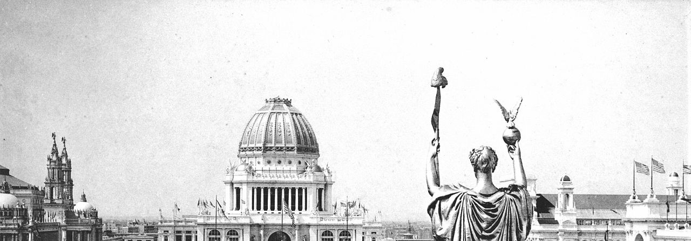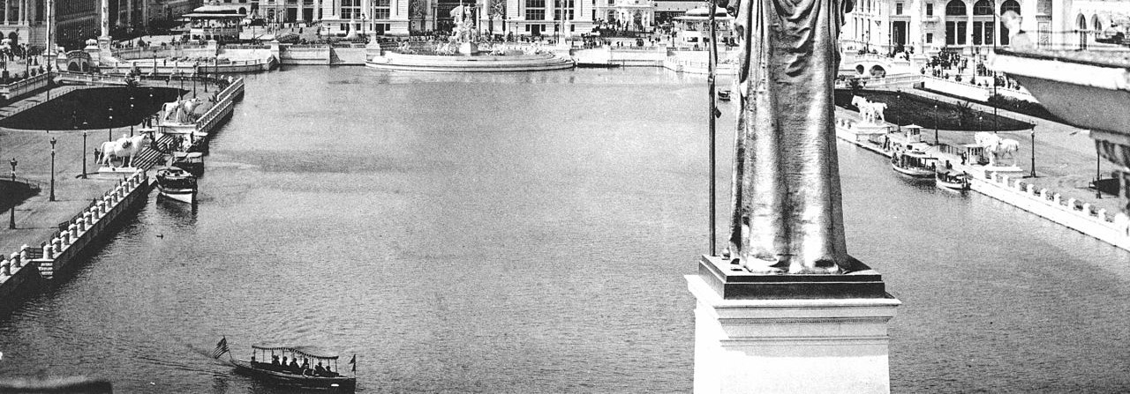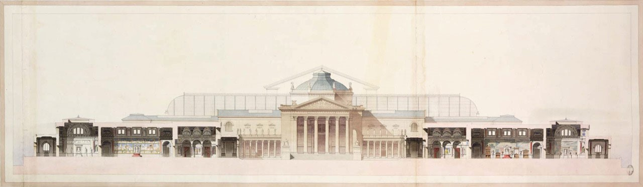
The Cook County Hospital Administration Building exemplifies the Classical Revival architectural style and the design influence of the Ecole des Beaux Arts. Classicism remained a vital architectural tradition in the early 20th century, and many large public buildings were designed in the style.

Top: The World’s Columbian Exposition, held in Chicago in 1893, encouraged the use of Classical forms and ornament for buildings built for a generation after the fair (from “Wikipedia” - https:// en.wikipedia.org/wiki/World%27s_Columbian_Exposition).

Bottom: An example of a drawing produced at the Ecole des Beaux-Arts. The Ecole, located in Paris, was the world’s leading architecture school in the 19th and early 20th centuries. Students attending the Ecole were taught how to design spatially-complex buildings using historic styles, especially Classicism (from “Pinterest” - https://www.pinterest.com/pin/333899759852458937/).
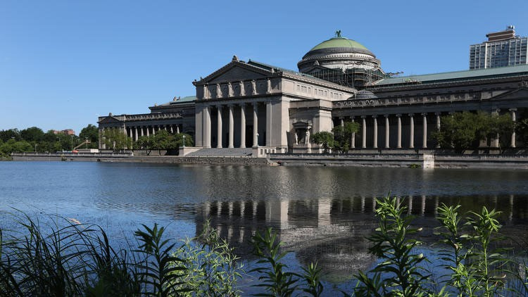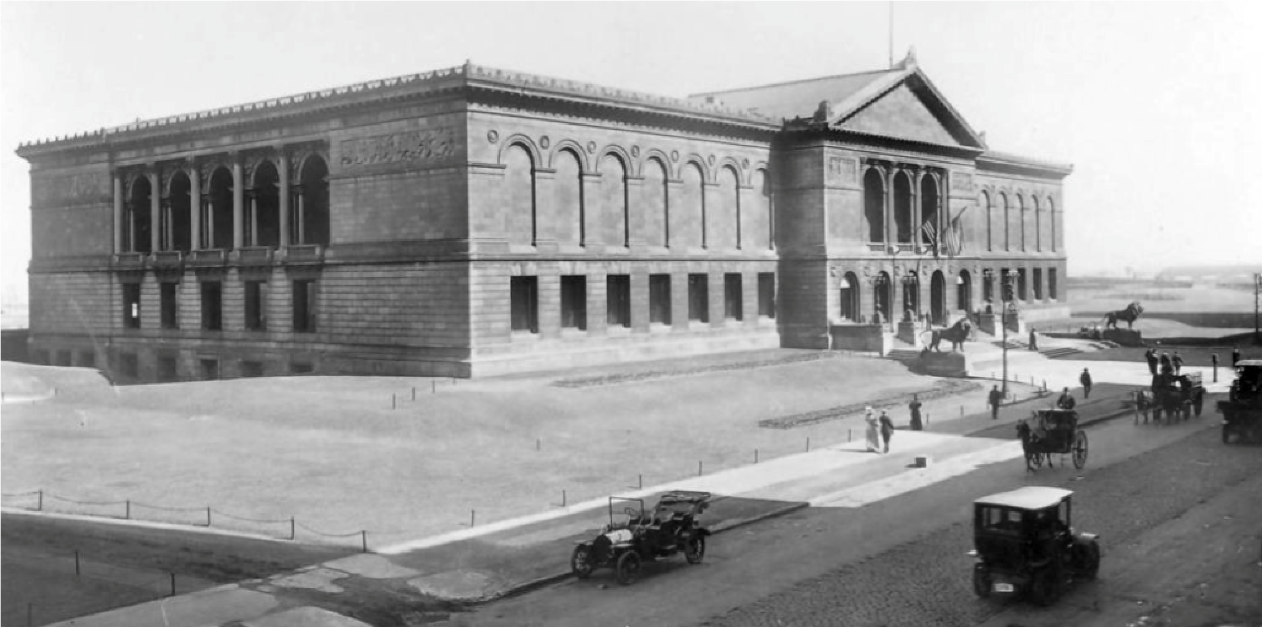
Two public buildings that were designed in the Classical Revival style and influenced by Ecole des Beaux-Arts teachings are (top) the Art Institute of Chicago and (bottom) the Museum of Science and Industry.

Top photograph from “Chicagology” website - https://chicagology.com/goldenage/goldenage023/

Bottom photograph from Chicago Tribune website - http://www.chicagotribune.com/entertainment/ museums/ct-ott-0714-museum-of-science-and-industry-chicago-top-ten-20170718-story.html
Through this combination of rationality and grand historic-based style, Cook County Hospital exemplifies the Ecole's teaching methods.

In Chicago, the World's Columbian Exposition encouraged the popularity of the Beaux-Arts architectural traditions and the use of Classicism. Held in Chicago's Jackson Park in 1893, the Exposition was a grandly-scaled example of Beaux-Arts ideals utilized for both the overall fair layout and the design of individual buildings. In the wake of the Exposition, for the next thirty years, buildings were built in Chicago utilizing Beaux-Arts methods of design and cloaked in the Classical Revival style.

Besides the Cook County Hospital Administration Building, other Classical Revival-style buildings in Chicago that were influenced by Beaux-Arts design ideals include the Museum of Science and Industry (originally the Fine Arts Pavilion of the World's Columbian Exposition), located at the northern end of Jackson Park (built 1891-1893, renovated 1929-1941); the original Allerton Building of the Art Institute of Chicago, located on South Michigan Avenue at Adams Street
(1893); City Hall-County Building, 118 N. Clark St. / 121 N. LaSalle St. (1905-1908, 1909-1911);
Union Station, 210 S. Canal St. (1913-1925); Chicago Cultural Center (formerly Chicago Public Library) 78 E. Washington St. (1897); and the Field Museum of Natural History (1909-1920). All of these buildings, except the Field Museum, are either individual Chicago Landmarks or contributing to a Chicago Landmark District.

A P G , S .

Paul Gerhardt, Sr. (1863-1951), the architect of the Cook County Hospital Administration
Building, was born in the town of Dobeln in what was then the Kingdom of Saxony (now part of
Germany). He attended the Royal Academy in Leipzig and earned an engineering degree at the Technical University of Hanover in 1884. He then came to the United States in 1890 at the behest of the German Textile Corporation to design and construct spinning mills. He designed one of the largest mills in the United States at the time¾the Botany Worsted Mill in Passaic, New Jersey. Gerhardt continued to take commissions for other large manufacturing facilities throughout his career, including a number of mill complexes, a plant for the International Gas Engine Company in LaPorte, Indiana, and a distillery in Elgin, Illinois.

Gerhardt came to Chicago in 1893 and soon started his own architectural firm, taking on various residential, commercial, and industrial projects. Prolific in the first decade of the twentieth century, his list of projects listed in the American Contractor, a trade publication, alone numbers nearly 70 between 1898 and 1910. Projects announced in the Chicago Daily Tribune from that period include apartment and flat buildings, such as the brownstone-clad “Roseberry Flats” on Elaine Street (1896). Additionally, by 1910, Gerhardt’s Who’s Who in Chicago listing cites him as the architect for “many warehouses, mercantile buildings, and hotels” in and around Chicago.

According to Frank A. Randall’s History of the Development of Building Construction in Chicago, Gerhardt’s work during this period included the Hall Building (1908, demolished), a seven-story industrial building of heavy mill construction located at 440-472 W. Superior St.; and the Winston Building (1911, demolished), a seven-story industrial building of flat slab construction and concrete exterior at 341-349 E. Ohio St. Some of his most noted designs in his early career in Chicago were hotels and restaurants for German clientele, including the first Bismarck Hotel and the Rienzi restaurant.

In December 1910, Gerhardt was picked to replace William Holabird as Cook County architect. Soon after, the Cook County Board announced that a new county hospital building would be constructed. As county architect, Gerhardt drew up designs for the new building, a visually impressive Beaux Arts-style building that remains on Chicago’s Near West Side along W. Harrison St. However, due to numerous clashes with the County Board over the hospital building and other issues, Gerhardt was forced to resign his post as County Architect in January 1913. The design of the hospital, which was completed within the year, remained Gerhardt’s, however, and it remains one of his best-known buildings.

After leaving his position as Cook County architect, Gerhardt returned to private practice until 1928, when he was chosen to serve as supervising architect for the Chicago Board of Education. Some of the more notable school buildings designed by Gerhardt during his three-year tenure, include the mammoth Lane Technical High School at 2501 W. Addison St. (1930) and the terracotta-ornamented Von Steuben High School at 5021-55 N. Kimball Ave. He also designed the Wright Junior College building in the 3400-block of North Austin Avenue (1929) and Amundsen High School in the 5100-block of North Damen Avenue (1929). The Parker Senior High School, built in 1929-1931, remains in the Englewood neighborhood in the 300-block of West Normal Parkway, while Steinmetz High School stands on the Northwest Side on the 3000-block of North
Melvina Avenue (1931-1935). One of Gerhardt's best-known school buildings is the Du Sable High School Building at 4934 S. Wabash Avenue (1931-1934), which was designated as a Chicago Landmark in 2012.

Two other buildings by Gerhardt are individual Chicago Landmarks. The Lindemann & Hoverson
Company Showroom and Warehouse Building at 2620 W. Washington Blvd. was built to house the Chicago offices of a Milwaukee-based appliance company. The Cairo Supper Club Building, built as a speculative one-story commercial building, is a rare example of the Egyptian Revival architectural style and quite visually distinctive with its multi-colored terra-cotta ornamental facade embellished with scarabs, lotus-capital columns, and other Egyptian decoration.

Other buildings known to be designed by Gerhardt in Chicago during this time period include the
Three Links Temple, now DANK-HAUS (a German cultural center) at 4740-48 N. Western
Avenue; the Schlake Dye Works Plant, 4203 W. Grand Avenue (1921); the Fraternal Order of Eagles Building (c. 1921, demolished), Carpenters’ District Council Building, and the Edgewater Athletic Club (c. 1928, demolished).

Although Paul Gerhardt, Sr. is best known for his municipal and school designs, he was a pioneer in industrial architecture for his efforts to increase the glazed wall area of reinforced concrete buildings. In 1917, Gerhardt patented a new type of industrial reinforced-concrete loft design, noteworthy for introducing continuous sash or window walls to industrial buildings. Patent number 1,243,281, dated October 16, 1917, proposed illuminating interior spaces by placing the supporting floor columns behind the sash line and extended floor slabs six inches to allow for continuous window walls. Gerhardt’s Winston Building (1917, demolished), located at 341-349 E. Ohio Street, was a seven-story industrial building of flat slab construction and concrete exterior that is considered the first structure to use this construction method.

M H A C C H

People seeking treatment at Cook County Hospital were first seen by staff in the Receiving Department, where they were screened to determine if they indeed were poor enough to qualify for medical care at the public hospital. Their symptoms were also evaluated, and they were then admitted to general or specialized wards, segregated by sex. Many patients received long-term care at Cook County. Over time, the facility provided important care for sufferers of major diseases of their time, including tuberculosis, polio and HIV/AIDS.

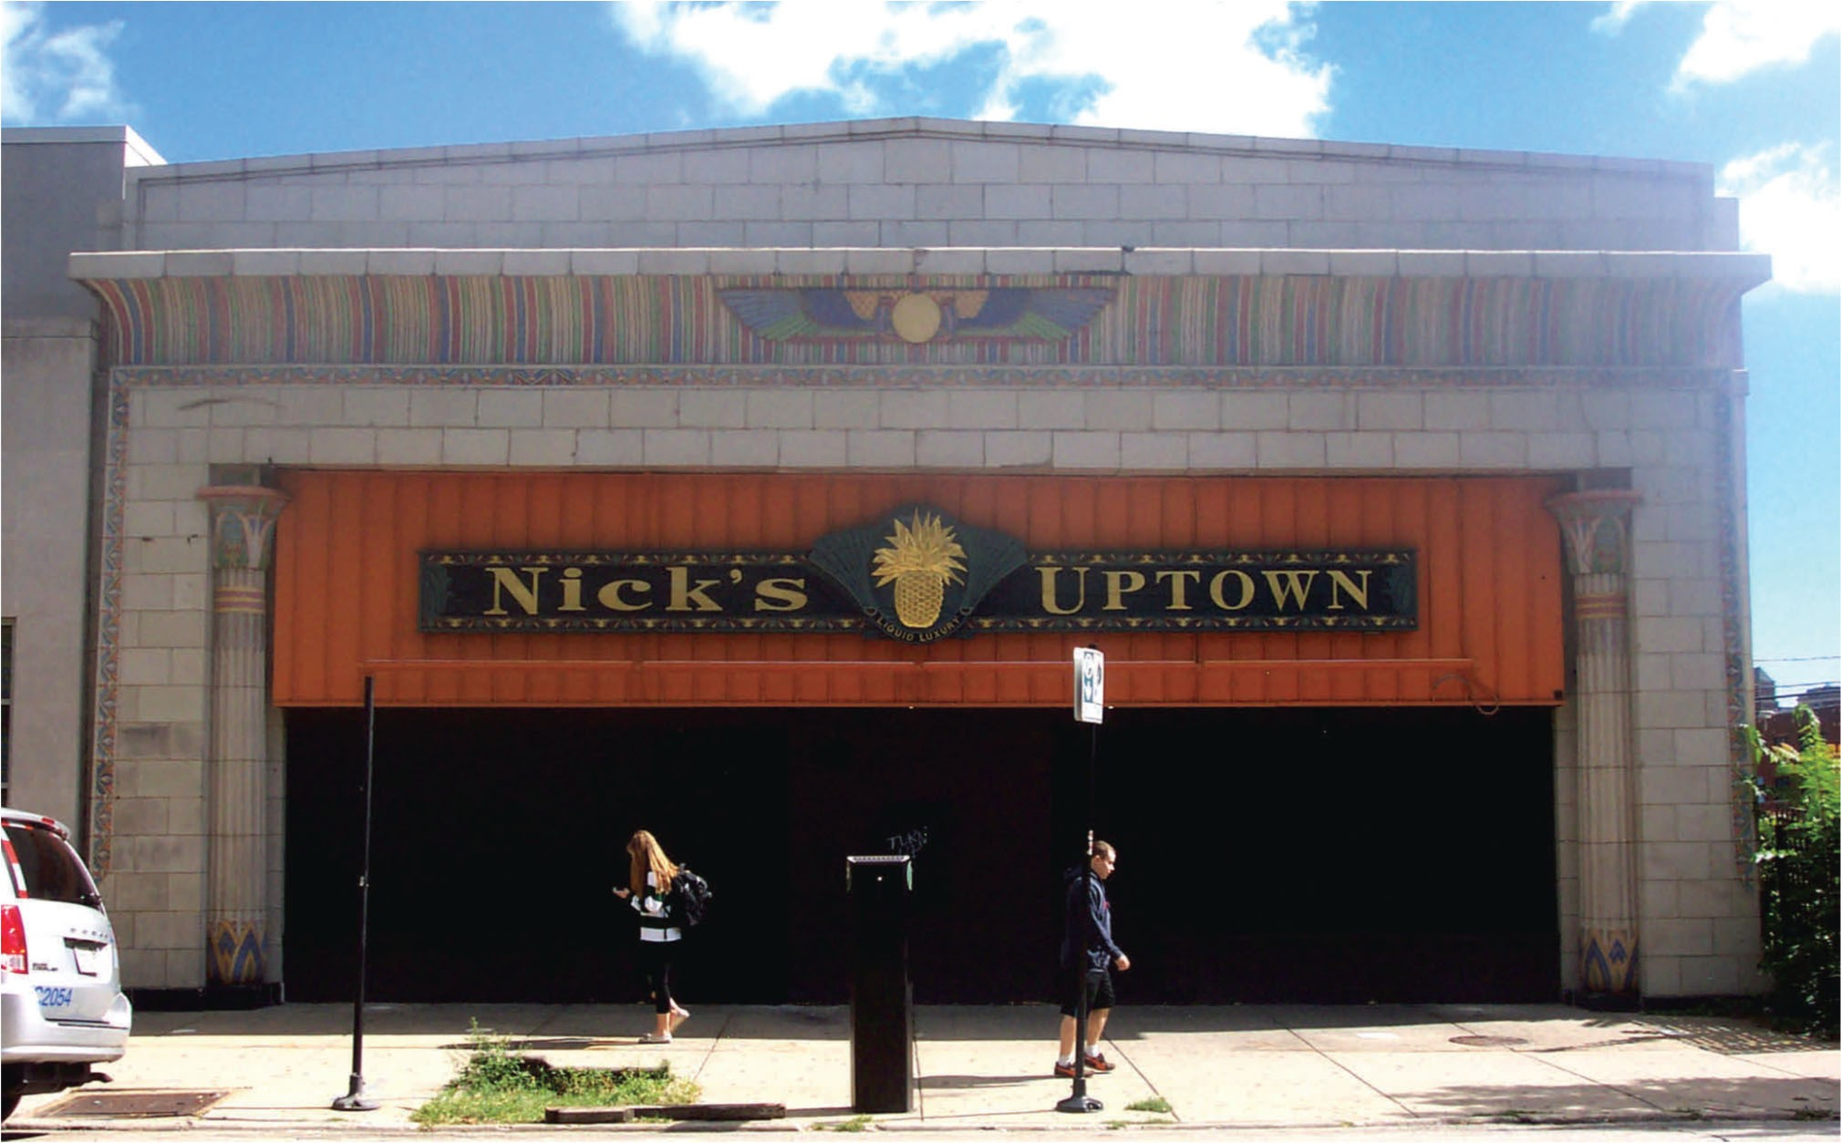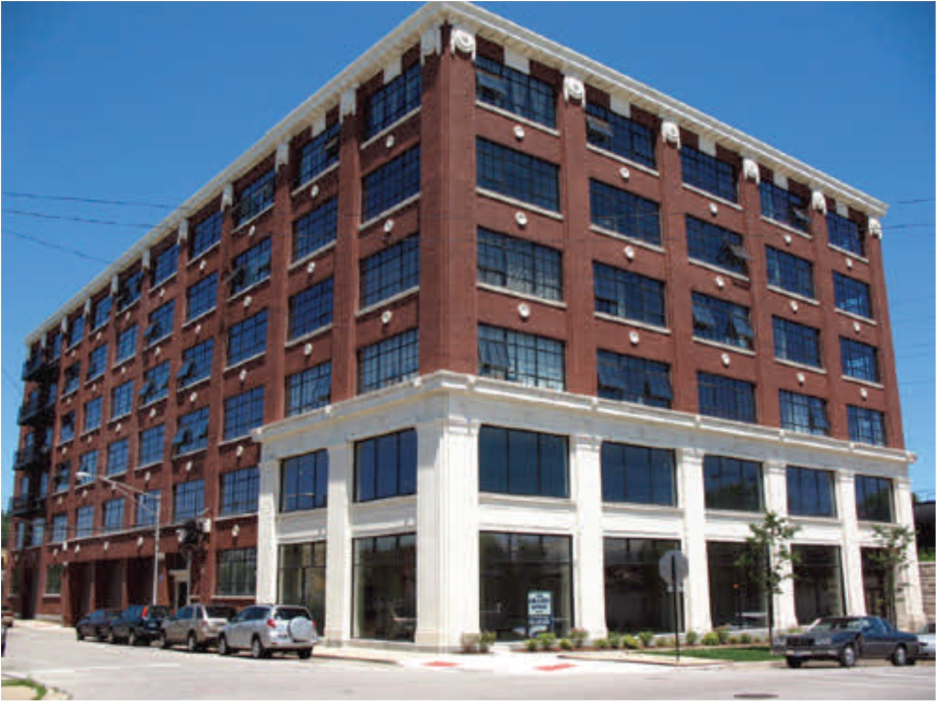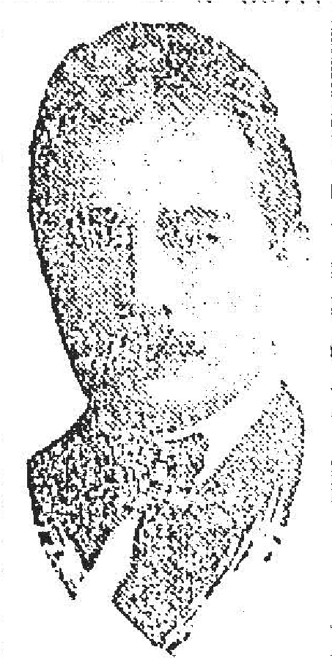
Paul Gerhardt, Sr., was the architect for the Cook County Hospital Administration Building. Top left: A portrait of Gerhardt published in the July 30, 1922, issue of the Chicago Daily Tribune.

Two buildings by Gerhardt that are individually-designated Chicago Landmarks are (top right) the
Lindemann & Hoverson Company Showroom and Warehouse Building, and (bottom) the Cairo Supper Club Building (photographs courtesy Historic Preservation Division, Department of Planning and Development).
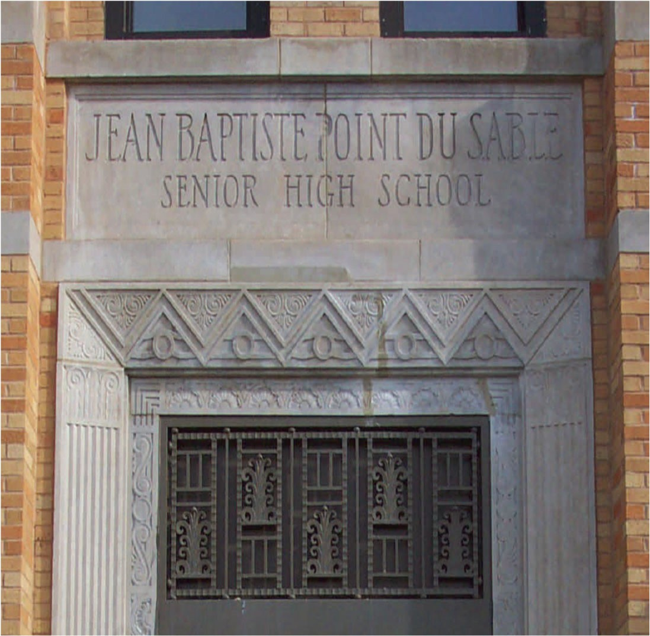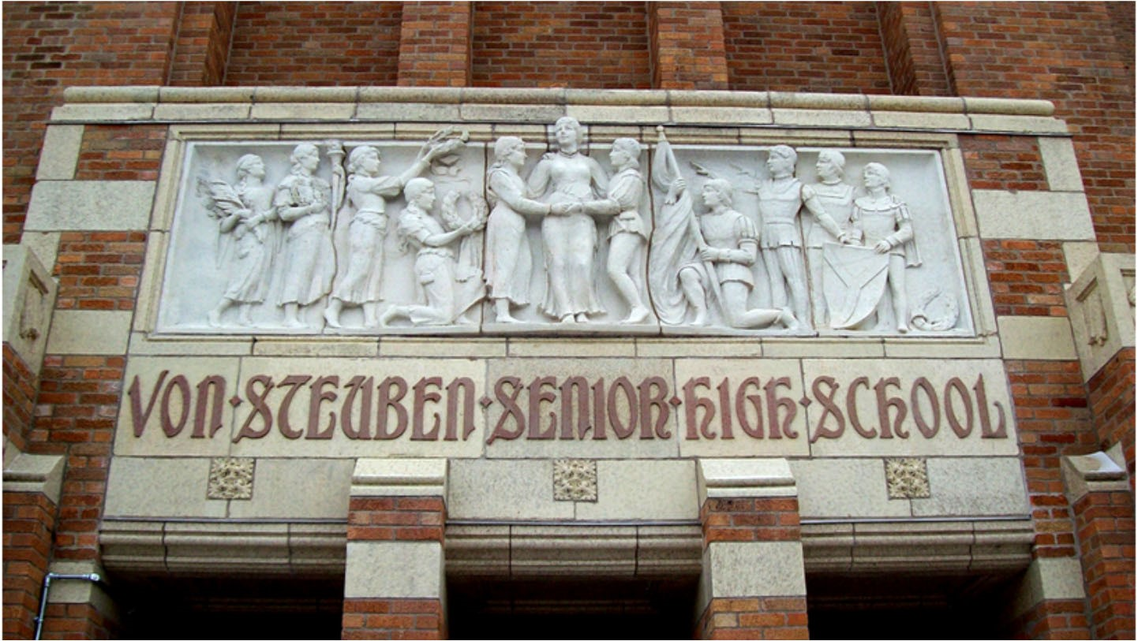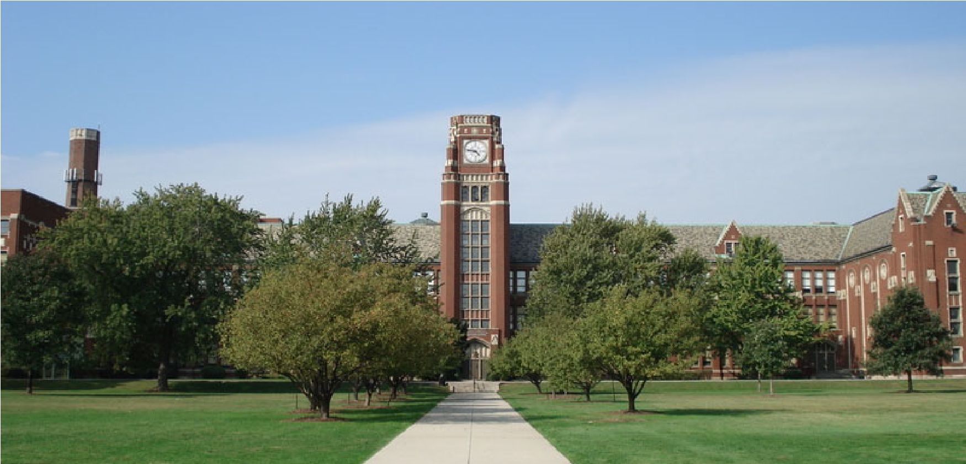
Gerhardt was Chicago School Architect
in the late 1920s and early 1930s. Three
of his school buildings are (top to
bottom) Lane Tech High School, Du Sable
High School, and Von Steuben High
School.

Photographs from (top) Wikipedia -
https://en.wikipedia.org/wiki/
Lane_Technical_College_Prep_High_Sch
ool; and (left and bottom) courtesy
Historic Preservation Division,
Department of Planning and
Development.
To help make long-term care easier for families, Cook County Hospital provided auxiliary services. A day nursery was established in 1915 that provided care for small children while their parents visited family members or friends receiving treatment in the hospital. A schoolroom for children in the hospital for long-term treatment was also in place in the 1910s. In 1918-1919, for example, an average of 28 children a day were students in this facility. Orthopedic patients began to receive occupational therapy such as woodcarving and weaving in 1917. This program was quite popular and was soon expanded throughout the hospital; it was disbanded during the early years of the Great Depression in 1932. The hospital received its own Chicago Public Library branch in 1921. There were even summer concerts performed on hospital grounds in the late 1910s and 1920s.

An important function of Cook County Hospital was the provision of outpatient services. Initially, outpatient clinics were scattered throughout the hospital building, but most were consolidated in one of the hospital pavilions in 1934. Outpatient services were moved out of the building in 1940 and into the former West Side Hospital at 1835 W. Harrison St., which the County purchased for this purpose. This new Fantus Clinic was named for blood bank pioneer Dr. Bernard Fantus. A later Fantus Clinic building replaced this repurposed hospital building in 1961.

Throughout its history, Cook County Hospital has been a hospital of last resort for poor Chicagoans of all backgrounds. When immigration to the United States was strong and bringing millions to the county each year in the early 20th century, so many newly-minted Chicagoans were served by Cook County Hospital that the institution was dubbed "Chicago's Statue of Liberty." A majority of patients (73 percent of 48,223 total patients) were immigrants when the construction of the Cook County Hospital Administration Building started in 1912. By 1921, the number of foreign-born patients had slipped to about 50 percent, and by 1927, after the United States had imposed strict immigration quotas, only 17 percent of Cook County's 43,251 patients had been born outside the United States.

As foreign-born patients no longer dominated the wards of Cook County Hospital, African Americans increasingly took their place. The Great Migration, which brought many Southern-born blacks to Northern and West Coast cities starting around World War I, greatly increased the African American population in Chicago. Because of economic discrimination, many black families needed the services of Cook County Hospital. Even more prosperous African Americans found that many private hospitals would not accept them as patients. Cook County remained, until the post-World War II era of civil rights advances, one of the few hospitals in Chicago that did not discriminate on the basis of race. One statistic illustrates the importance of this public hospital to African American Chicagoans: 60 percent of all African American babies born in Cook County were delivered by doctors at Cook County Hospital.

Cook County Hospital's importance can be further illustrated by how it reflected Chicago society in the 1920s and 1930s. During the Prohibition years of the 1920s, hundreds of cases of poisoning from alcohol substitutes were handled at Cook County. The hospital also handled increasing numbers of gunshot wounds during the late-1920s "wars" between rival groups of gangsters. The Depression years of the 1930s saw many Chicago families, devastated by financial ruin, turning to
Cook County Hospital for medical needs. In October 1929, at the time of the stock market crash, Cook County Hospital was handling an average of 2,069 patients per day. By July 1935, the daily average had increased to 2,661. In 1940, it topped 3,000.

As an institution with roots in the Civil War era, Cook County Hospital has seen a number of innovations in medicine over time. Perhaps the most nationally significant was the creation of the first blood bank in the United States by Dr. Bernard Fantus. It opened on March 15, 1937. Dr. Fantus was the hospital's director of therapeutics and a University of Illinois College of Medicine professor. A long-standing problem in medical care was the variable availability of blood for transfusions during surgeries and the treatment of trauma. Others had solved issues involving storage, but Dr. Fantus was the first to refine the concept of a blood storage facility where donors could give blood for storage and later use. His coining of the term "blood bank" created a memorable phrase, conjuring up the image of a traditional "money bank," that caught the attention of the general public and which served as a marketing tool encouraging individuals to donate blood for use by others.

In the 1939 Cook County Hospital annual report, County Board President Clayton Smith noted:

The Blood Preservation Laboratory is called the Blood Bank because it functions like a bank in that the staff physicians are able to deposit blood, no matter of what type, to their credit in the bank. Then they are able to draw from the blood bank blood of the desired type on short notice. This has done away with the necessity of bleeding half a dozen or more persons in order to secure a type of blood required of the patient.

Early on, the blood bank acquired blood through both volunteers giving blood and payments to donors. Over time, blood drives became a part of everyday life through corporate sponsorship, especially through the American Red Cross.

The significance of Dr. Fantus's achievement is profound. Formerly, patients too often died waiting for compatible blood from a donor. The use of Cook County's blood bank grew rapidly after its establishment in 1937. The Chicago Daily Tribune reported that the number of blood transfusions per month grew ten-fold between 1937 and 1940, from 70 a month before the blood bank to 700 a month afterwards. In addition, Cook County Hospital provided blood for other Chicago-area hospitals. The concept of a blood bank quickly spread through the country, with as many as fifty large American hospitals establishing such facilities within three years of the start of the blood bank at Cook County Hospital.

It is believed that Dr. Fantus was the first person to propose the creation of a "medical park" or medical district for Chicago's West Side, recognizing and capitalizing on both public and private medical institutions in place there. Sadly, Dr. Fantus died in 1940, a year before the Illinois state legislature established the Illinois Medical District. Cook County Hospital's central outpatient clinic was renamed the Fantus Center in the doctor's honor.

The first modern medical internship program in the United States was established at Cook County Hospital in 1866 when Dr. Nils I. Quales was named the Hospital's first intern. At the time, doctors at Cook County were volunteers, providing care at the hospital in addition to their paying private practices. Consequently, they were unable to be in attendance except in limited circumstances. The need for trained medical staff around the clock led to the use of medical students to provide "work-horse" care of hospital patients. Cook County was the first institution to require such students to be graduates of medical schools. Raffensperger notes that such medical internships were "an innovation in medical education, as well as in the care of hospital patients."

At Cook County, from the beginning, competitive examinations determined who would receive coveted internships. Interns were not paid, but they did receive room and board in a dormitory-like room at the hospital, as much to ensure their availability when needed. Interns, in Raffensperger's word, "were required to visit each patient, morning and evening, and to notify the attending physicians of any emergencies." Originally, interns were brought into the hospital for three sixmonth rotations, each with a different set of duties. In later years, each six-month stint involved a different area of medical practice, including general medicine, surgery, and obstetrics/gynecology.

Cook County Hospital has been an important institution for nursing education. In 1881, trained student nurses from the Illinois Training School for Nurses were brought to the hospital to provide patient care, replacing the previous reliance on untrained attendants. In 1929, the Cook County
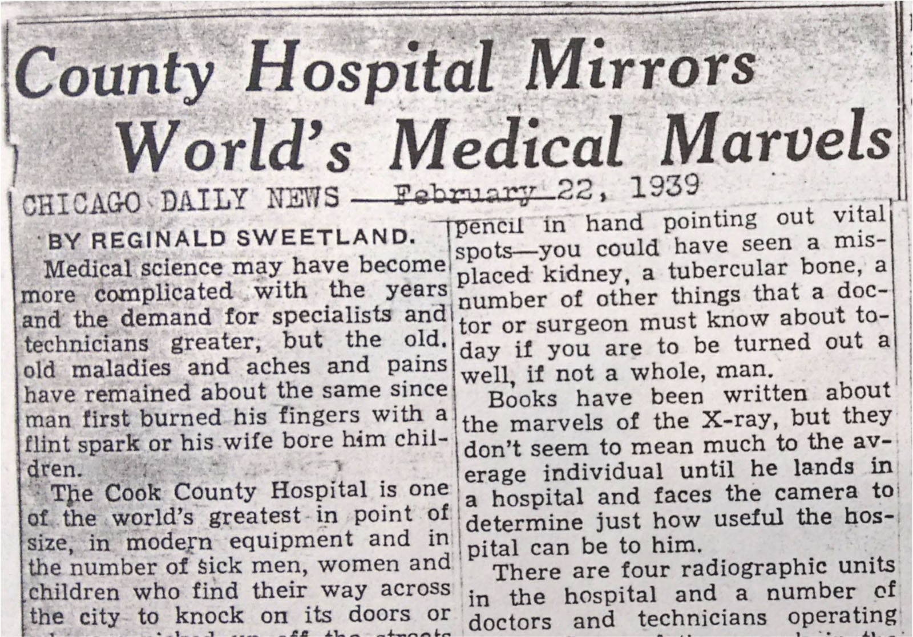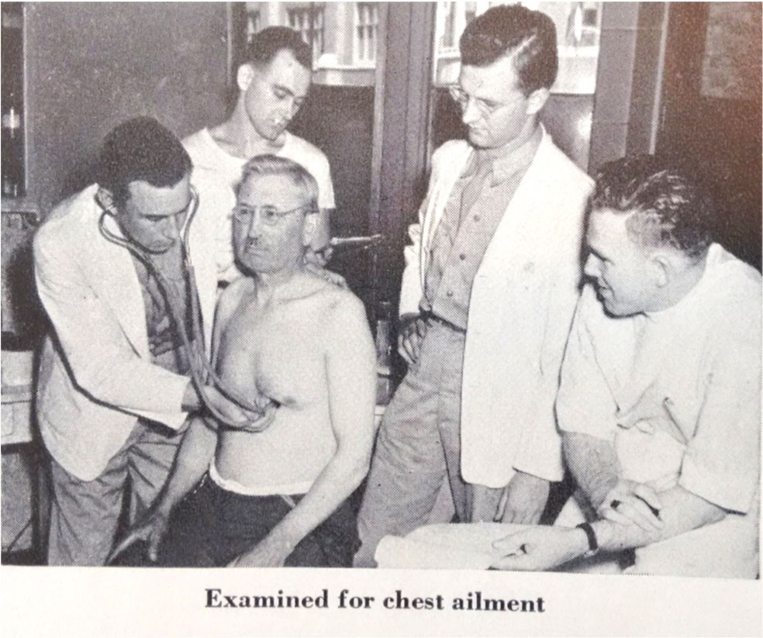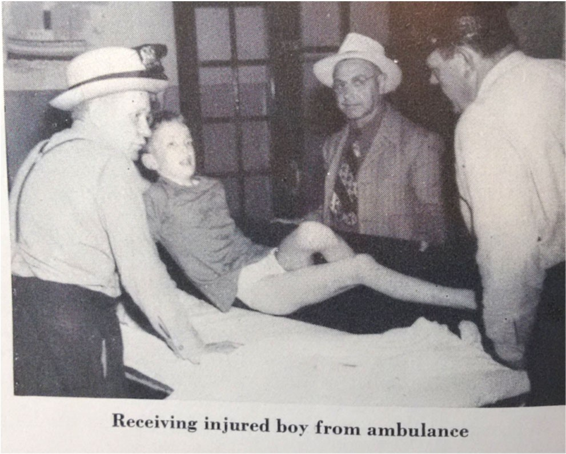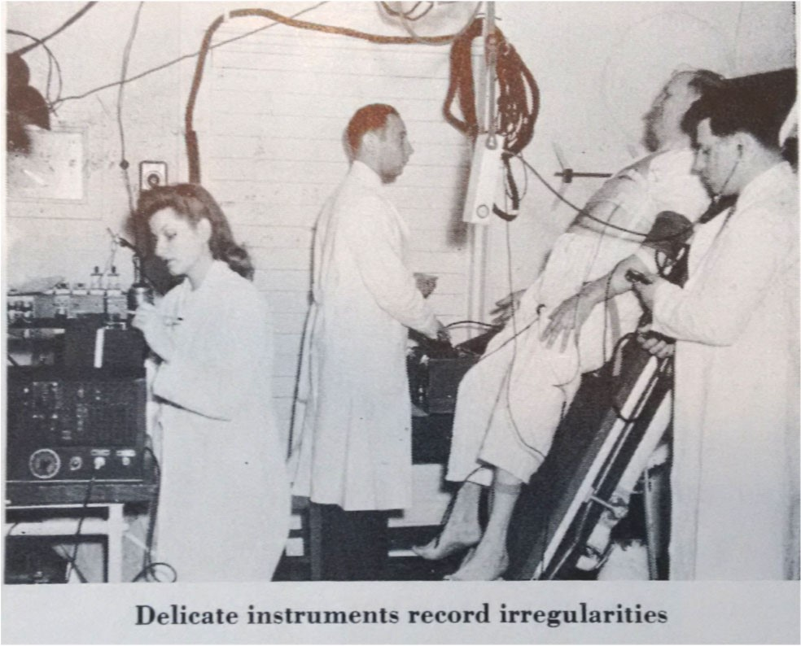
Throughout its history, Cook County Hospital
was a vitally-important hospital for Cook
County. Top: a
Chicago Daily News
article
from February 22, 1939, notes that the
hospital was one of the world’s largest at that
point in time.

This page’s photographs, taken from the
Medical Center District Fact book
of 1948,
show scenes of medical care at Cook County
Hospital in the period just after World War II.

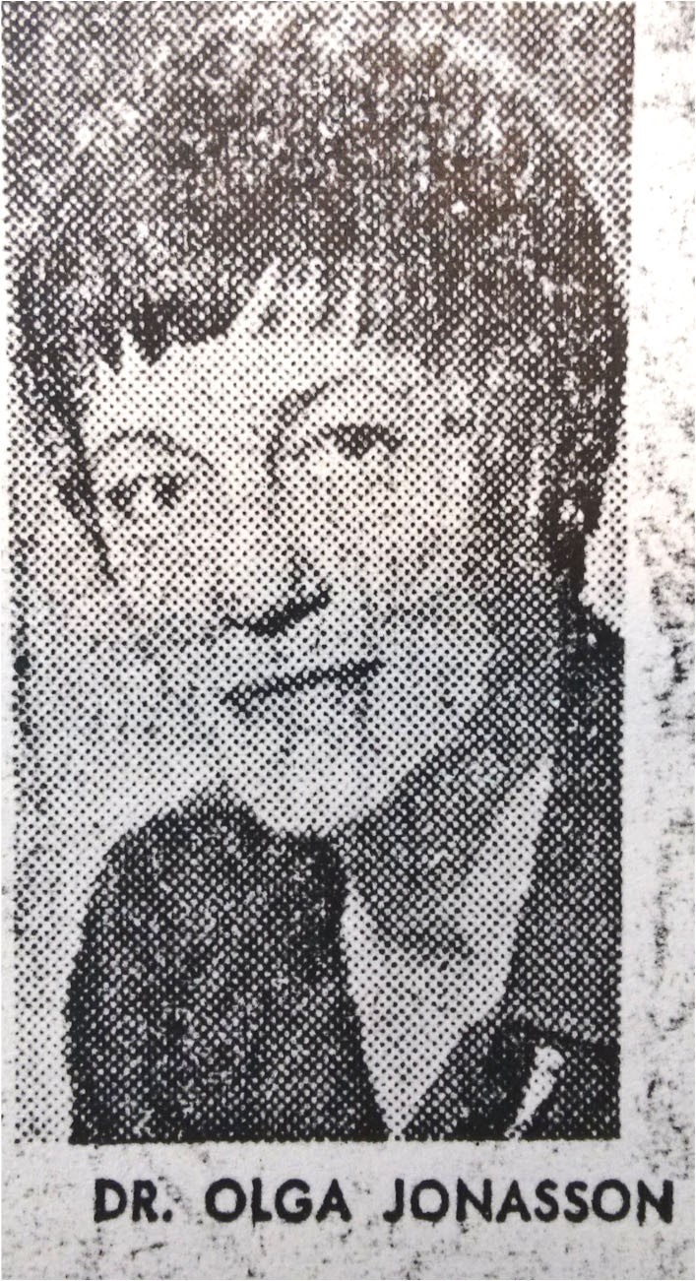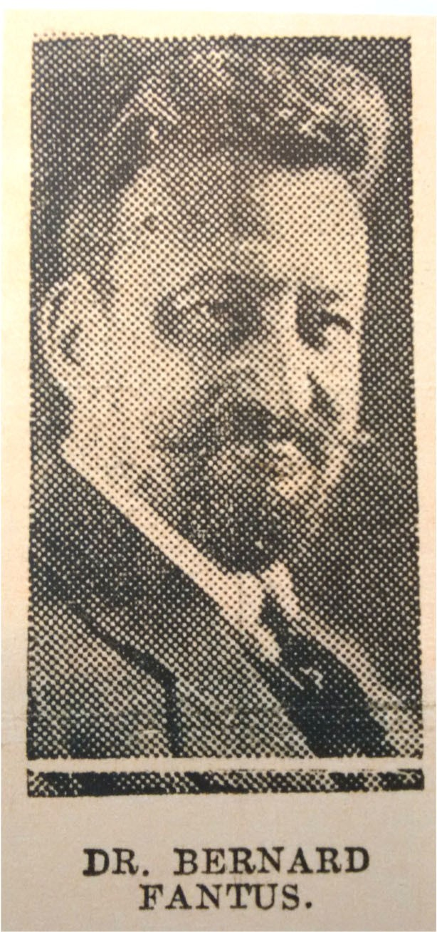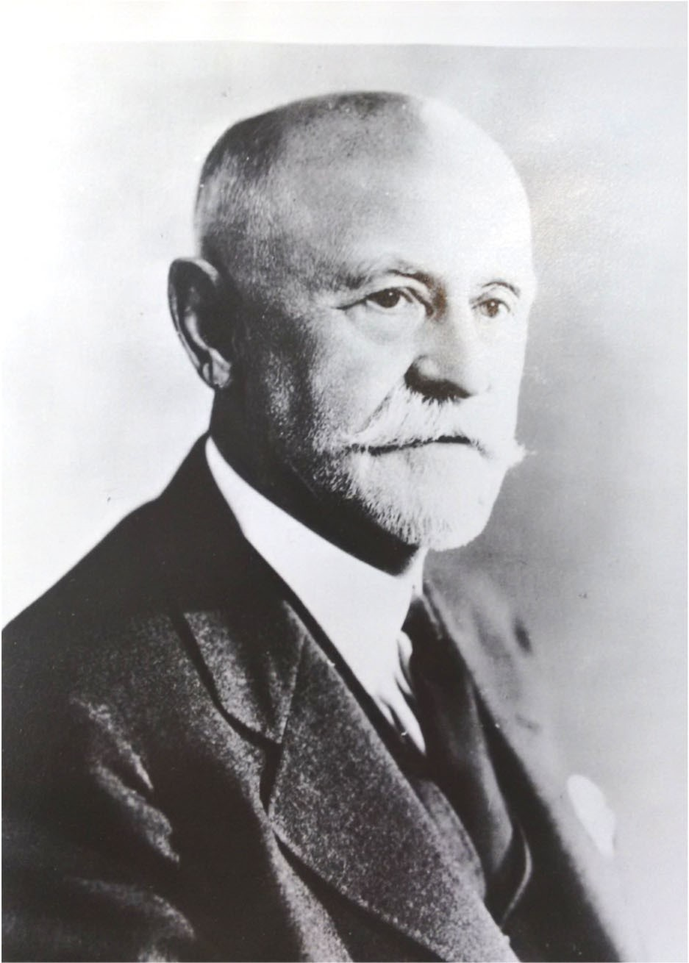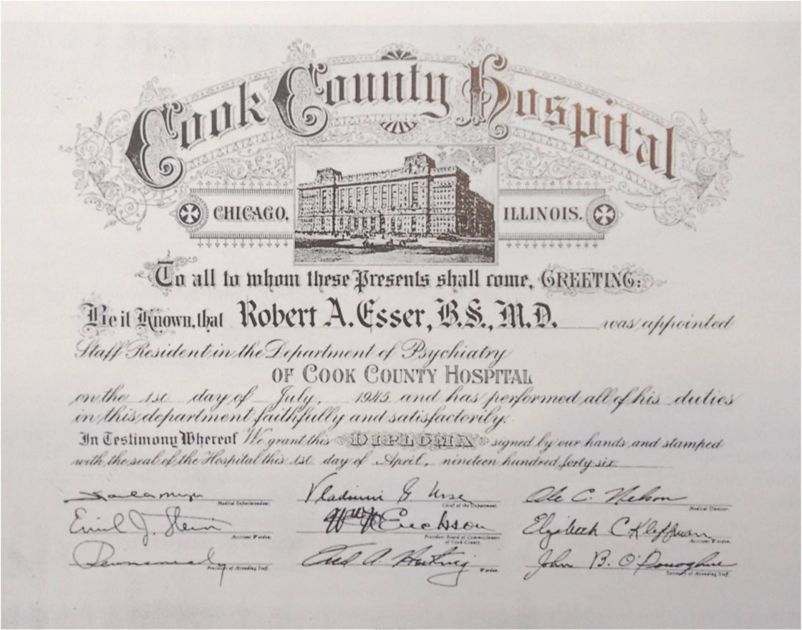
Doctors associated with Cook County Hospital include (top
left) Dr. James Herrick, who identified the cause of sickle-cell
disease; (top right) Dr. Bernard Fantus, who established the
first “blood bank” in a United States hospital; and (left) Dr.
Olga Janasson, the first woman to be head of surgery at a
major American hospital.

As importantly, many doctors went through internships and
residencies at Cook County Hospital over the decades.
Bottom right: A certificate of residency for one of these many
young doctors.

School of Nursing opened, supplanting this earlier institution, with the mission to provide nurses for Cook County Hospital and allied institutions. The nursing school continued until 1980, during this time building its own building nearby at 1900 W. Polk St. to house offices, classrooms, and student housing.

The study of pathology, or the medical field concerned with underlying disease processes, began in the Midwest with the work of one of Cook County Hospital's most important early doctors, Dr. Christian Fenger. It remained a vital focus of work at the hospital over time. In the 1920s, the hospital's Pathology Department began weekly conferences, attended by medical professionals, to discuss findings from the hundreds of annual post-mortem examinations undertaken by hospital staff. Such conferences were intended to make more available cutting-edge information on disease and medical treatments. The luster of these weekly pathology conferences was such that, by 1937, over 900 American and foreign doctors attended the conferences that year, with some remaining in residence for months at a time to receive this early form of continuing education.

In addition, the Cook County Hospital Pathology Department was a leader in medical publications. In 1933 alone, the department's staff published 20 papers in medical journals. In the 1950, weekly pathology lectures were often published in an annual publication, "Clinical Pathological Conferences” at Cook County Hospital.

Sickle-cell anemia, a genetic disease often afflicting African Americans, was first identified in 1904 by Dr. James B. Herrick, one of the medical staff at Cook County Hospital. Dr. Herrick was working with a wealthy black resident of Granada, Walter Clement Noel, who had come to Chicago to study dentistry. His blood revealed sickle-shaped red blood cells that Herrick identified as a cause of anemia. Herrick and his intern, Dr. Ernest E. Irons, observed Noel regularly for several years and published a medical journal article on their findings in 1910. Herrick's care of Noel took place at the neighboring private Presbyterian Hospital, but his close association with Cook County Hospital has linked his sickle-cell research to the public hospital.

Dr. Herrick also is associated with other important medical advances. In a 1912 medical journal article, he first correctly speculated that heart attacks were caused by clots in the heart's blood vessels. In 1918, Herrick was among the first researchers to advocate for the use of electrocardiography in diagnosing heart attacks.

More recently, Cook County Hospital was a pioneer in recognizing the important role of women medical professionals. Dr. Rowine Hayes Brown became medical director of Cook County Hospital in 1973. A lawyer and pediatrician noted for her work with abused children, Dr. Hayes, was the first woman in the United States that was named the medical director of a major hospital. Four years later, Dr. Olga Jonasson, a surgeon and professor at the nearby University of Illinois Medical Center, became head of surgery at Cook County Hospital. She was the first to achieve such a position in any major hospital in the country.

Polio was a scourge that devastated many American families during the 20th century. Dr. John W. Nuzum, a Cook County pathologist, developed a serum in 1917 which proved somewhat effective in the treatment of polio. Nuzum also developed a vaccine that assisted in the fight against the 1918 influenza epidemic, one of the great pandemics in world history. Nuzum's vaccine was administered to all staff at Cook County Hospital and was distributed to other hospitals in Chicago and around the United States.

An advance in orthopedics occurred at Cook County Hospital in 1937, when Drs. James J. Callahan and Carlo Scuderi developed an innovative use of steel pins to stabilize hip fractures. This was a major advance in broken-bone treatments, stabilizing the break enough to allow patient mobility on cruches. Previously, many elderly patients, immobilized with broken hips, died from pneumonia and secondary complications.

L H

The Cook County Hospital Administration Building received many additions over time. Two of four rear pavilions, six stories in height, were built in 1914 and 1915, while two other six-story pavilions were built in 1917. A three-story Receiving Building was added in 1927 to the rear of the building. One-story rear additions filled in courtyard space between pavilions in 1950, and the Receiving Building was enlarged in 1956-1957. The four-story Fantus Clinic, which provided outpatient care, was built to the west of the Administration Building in 1961. An enclosed groundfloor connector was added later. All of these additions were demolished in the years following the hospital's closing in 2002, with much of the land now used for surface parking. The building's exterior cornice was removed in 1960.

The Cook County Hospital Administration Building was closed in December 2002 when the new John H. Stroger, Jr., Hospital of Cook County opened to the southwest. Originally slated for complete demolition, the Administration Building was spared by the Cook County Board of Commissioners. It was listed on the National Register of Historic Places in 2006, and it is "orangerated" in the Chicago Historic Resources Survey. Current plans for the building call for its rehabilitation by a private developer for new uses, including retail, office and museum uses on the ground floor and a mix of office and hotel uses on upper floors. Chicago Landmark designation would make available the Cook County Class L property tax assessment incentive for rehabilitation.

C D

According to the Municipal Code of Chicago (Sections 2-120-690), the Commission on Chicago Landmarks has the authority to make a recommendation of landmark designation for an area, district, place, building, structure, work of art or other object with the City of Chicago if the Commission determines it meets two or more of the stated “criteria for designation,” as well as possesses a significant degree of historic integrity to convey its significance.

The following should be considered by the Commission on Chicago Landmarks in determining whether to recommend that Saint Peter’s Episcopal Church and Parish House be designated as a Chicago Landmark.

Criterion 1: Value as an Example of City, State, or National Heritage
Its value as an example of the architectural, cultural, economic, historic, social, or other aspect of the heritage of the City of Chicago, the State of Illinois, or the United States.

- The Cook County Hospital Administration Building exemplifies the vital role of public hospitals providing medical care to the poor throughout the history of Chicago and Cook County. From 1914 to 2002, the Cook County Hospital Administration Building served many of the County's marginalized populations, including immigrants and African Americans.

- Doctors working for and associated with Cook County Hospital have been instrumental in medical advances, including the development of the nation's first blood bank, the discovery of the cause of sickle-cell anemia, and the development of modern medical internship programs, among others.
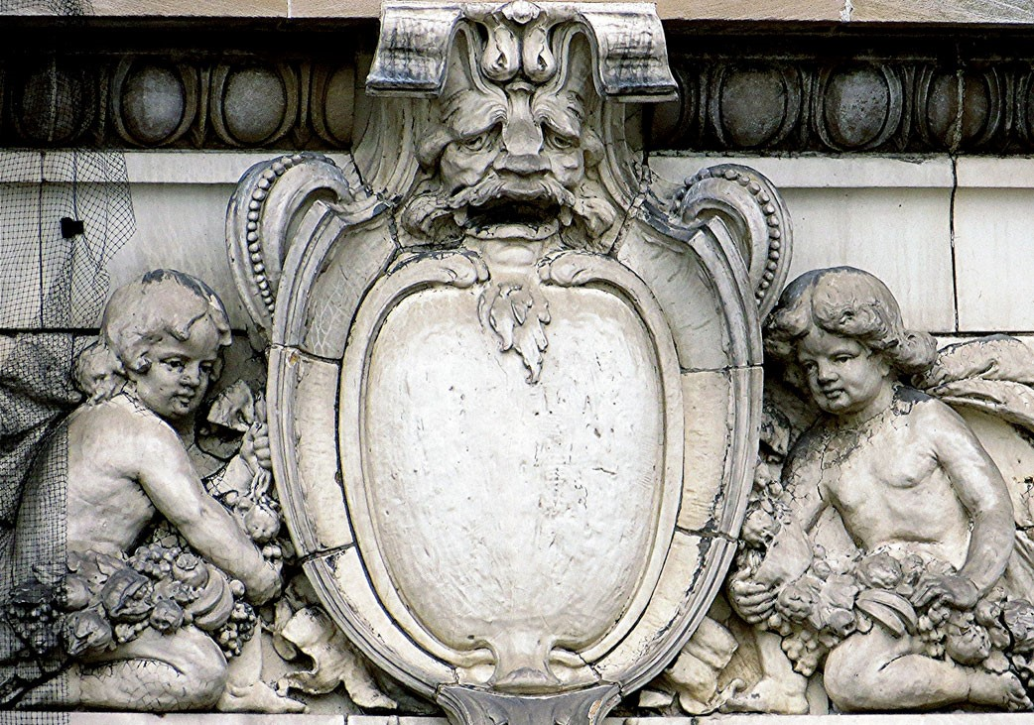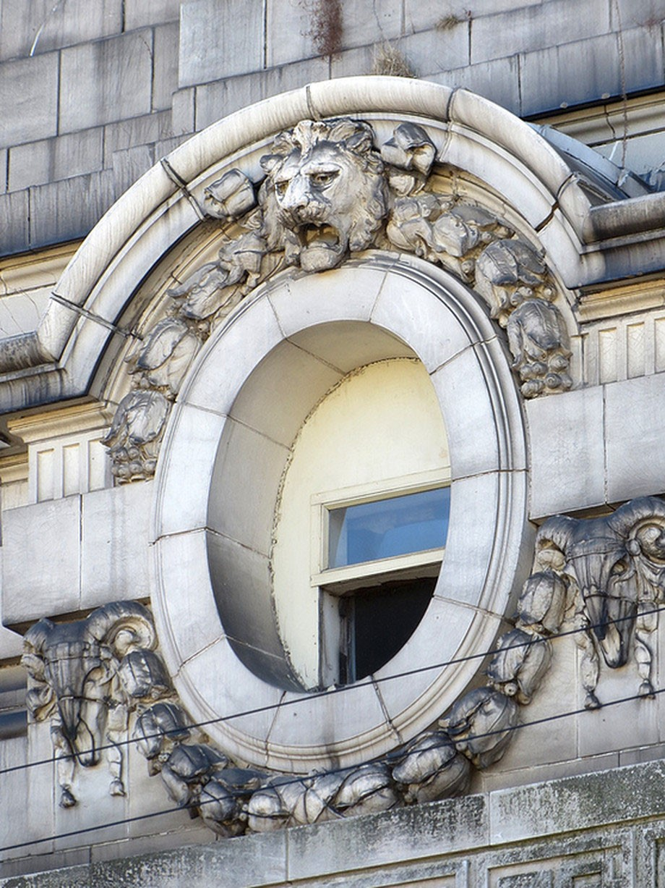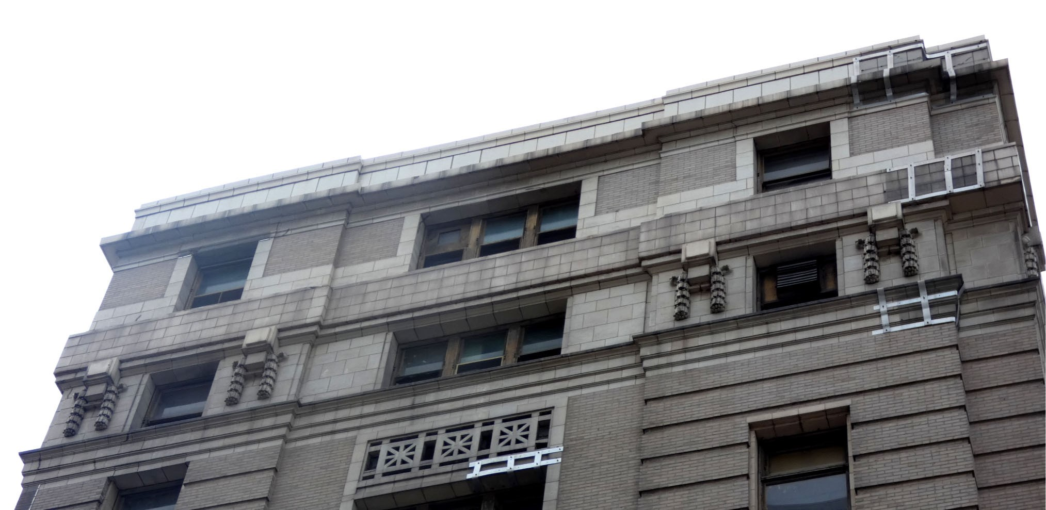
Details of ornament on the exterior of the Cook County Hospital Administration Building.

Photographs from (clockwise from top left) “Curbed Chicago” website (https:// chicago.curbed.com/2014/9/24/10043556/fate-of-old-cook-county-hospital-to-be-decided-in-comingweeks) (top two photos) and Macrostie Historic Advisors.

Criterion 4: Exemplary Architecture
Its exemplification of an architectural type or style distinguished by innovation, rarity, uniqueness, or overall quality of design, detail, materials, or craftsmanship.

- The Cook County Hospital Administration Building is one of Chicago's grandest Classical Revival-style public buildings in the Beaux-Arts design tradition.

- The exterior of the Cook County Hospital Administration Building is finely designed and crafted with Classical-style ornament executed in terra cotta.

Criterion 5: Important Architect
Its identification as the work of an architect, designer, engineer, or builder whose individual work is significant in the history or development of the City of Chicago, the State of Illinois, or the United States.

- Paul Gerhardt, Sr., the architect of the Cook County Hospital Administration Building, is a significant architect in the history of Chicago architecture, designing a variety of significant public, educational, commercial, and other buildings.

- Gerhardt was Chicago Board of Education architect from 1929 to 1931, during which time he designed such noteworthy school buildings as Lane Technical High School, Von Steuben High School, and Du Sable High School (a designated Chicago Landmark).

- Gerhardt designed two other individual Chicago Landmarks, the Cairo Supper Club Building at 4015-4017 N. Sheridan Rd. (built 1920) and the Lindemann & Hoverson Showroom and Warehouse Building at 2620 W. Washington Blvd. (built 1924).

Criterion 7: Unique or Distinctive Visual Feature
Its unique location of distinctive physical presence representing an established and familiar visual feature of a neighborhood, community or City of Chicago.

•  The Cook County Hospital Administration Building is a visual "landmark" on Chicago's West Side due to its great scale, its visually-striking Classical Revival-style exterior, and its location near the Eisenhower Expressway, easily visible to thousands of people commuting each day by car and the Chicago Transit Authority's Blue Line.

Integrity Criteria
The integrity of the proposed landmark must be preserved in light of its location, design, setting, materials, workmanship and ability to express its historic community, architecture or aesthetic interest or value.

The Cook County Hospital Administration Building has very good historic integrity. It retains its original site, overall building form and character-defining exterior and interior details. It retains historic window patterns, openings and sash, and its main entrance off Harrison Street.

Changes to the building include a modern canopy over the building's main Harrison Street entrance. The building's exterior has temporary restraints that are holding in place facade elements, including terra cotta and brick, in anticipation of rehabilitation. The exterior cornice was removed in 1960. Inside, the building's main first-floor lobby was originally a two-story space with Classical-style columns supporting a balcony. It was remodeled in 1939 with federal Works
Progress Administration (WPA) assistance; the resulting space had murals and the "Protection"
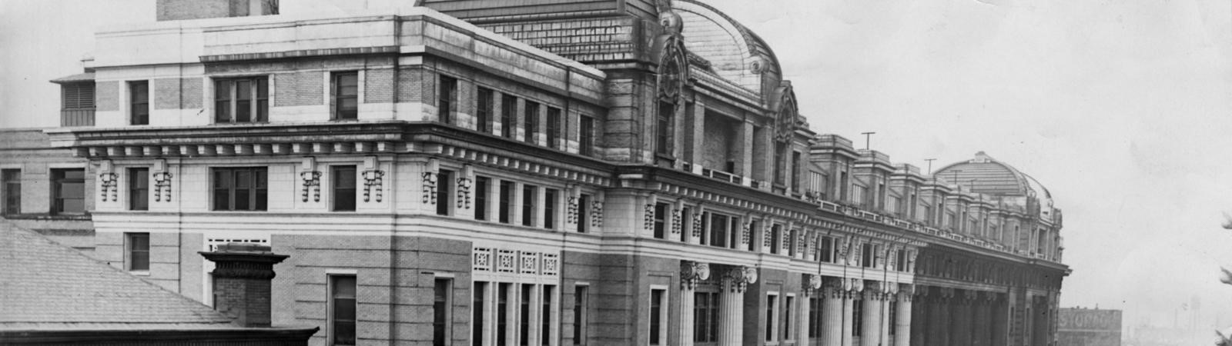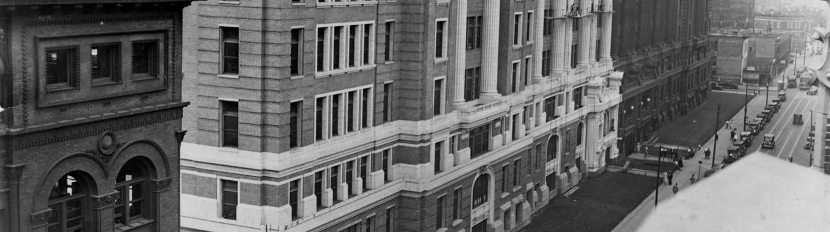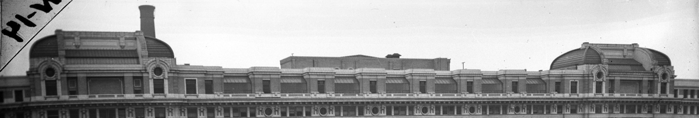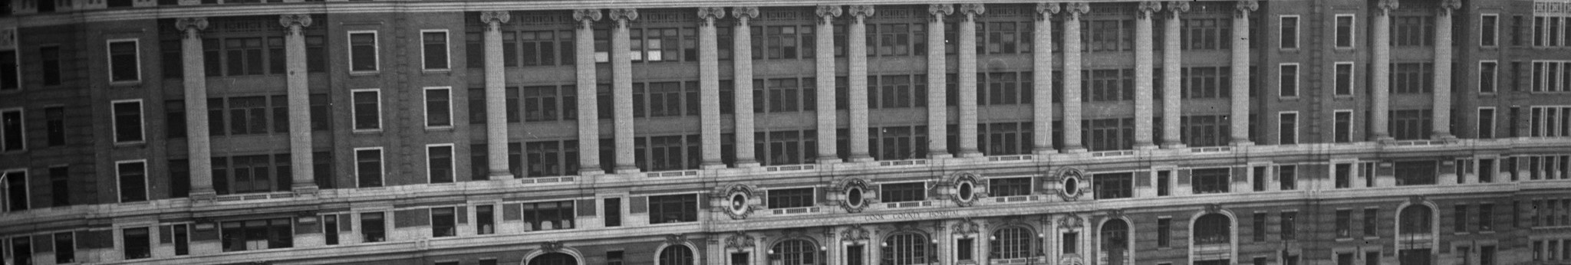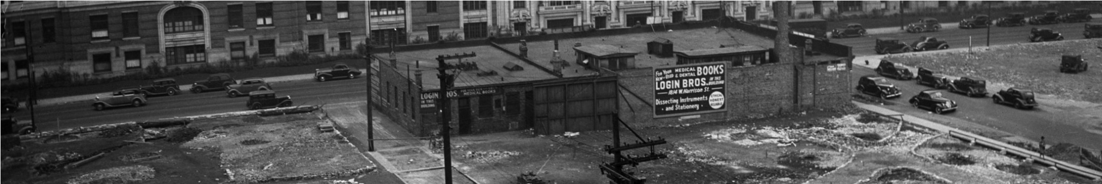
Historic photographs of the Cook County Hospital Administration Building from (top) 1933 (while its exterior was being cleaned) and (bottom) circa 1930s.

Photographs courtesy MacRostie Historic Advisors.
sculpture of women and children by artist Charles Umlauf. A dropped ceiling has since been added to the space, and artistic elements were removed over time.

Despite these changes, the Cook County Hospital Administration Building retains more than sufficient historic integrity for Chicago Landmark designation. As Chicago's long-time public hospital building, it exemplifies the importance of medical care to the citizens of Chicago. It is one of the most important buildings designed by significant architect Paul Gerhardt, Sr. It exemplifies the historic importance of the Classical Revival architectural style and the Ecole des Beaux-Arts design traditions to Chicago. Its unusual scale and visibility to the Eisenhower Expressway make it a unique visual "landmark" within the context of Chicago. Its historic and architectural significance has been preserved in light of its location, overall design, setting, materials, workmanship and ability to express its historic and architectural value to the City of Chicago.

S H A F

Whenever an area, district, place, building, structure, work of art or other object is under consideration for landmark designation, the Commission on Chicago Landmarks is required to identify the “significant historical and architectural features” of the property. This is done to enable the owners and the public to understand which elements are considered most important to preserve the historical and architectural character of the proposed landmark.

Based upon its evaluation of the Cook County Hospital Administration Building, the Commission staff recommends that the significant features be identified as:

•  All exterior elevations, including rooflines, of the building.

S B

Chicago Medical Society. History of Medicine and Surgery and Physicians and Surgeons of Chicago. Chicago: Biographical Publishing Co., 1922.
Encyclopedia of Chicago. Website available through the Chicago History Museum, http:// encyclopedia.chicagohistory.org/; accessed November 30, 2016.
Liechty, Jason, and Mike Quigley. "Cook County Hospital Administration Building," National Register of Historic Places nomination, 2006.
Raffensperger, John G. The Old Lady on Harrison Street: Cook County Hospital, 1833-1995.
(International Healthcare Ethics series, v. 3). New York: Peter Lang Publishing, 1997.
Chicago Daily Tribune, various articles.
Chicago Record-Herald, May 23, 1912.

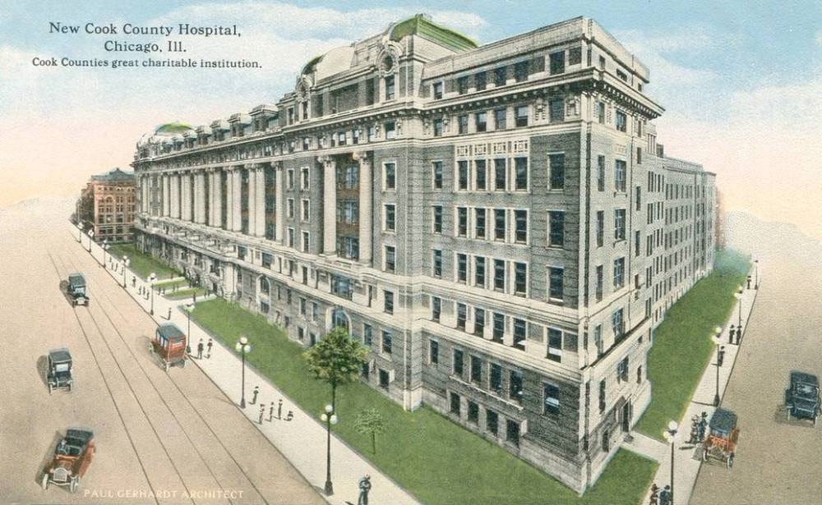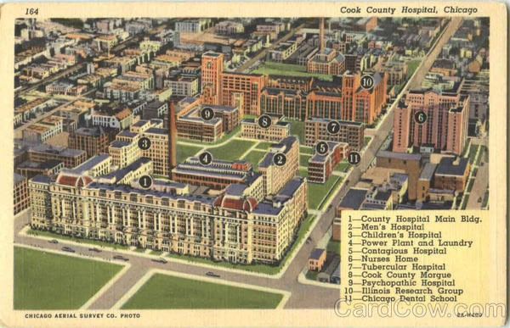
Historic postcards of the Cook County Hospital Administration Building
(from https://chuckmanchicagonostalgia.wordpress.com/2015/08/07/postcard-chicago-cook-countyhospital-new-building-built-in-1916/ and http://hekint.org/2017/02/22/the-old-cook-county-hospital-ofchicago/)
A

CITY OF CHICAGO
Rahm Emanuel, Mayor

Department of Planning and Development
David Reifman, Commissioner
Patricia A. Scudiero, Managing Deputy Commissioner, Bureau of Zoning and Land Use
Eleanor Esser Gorski, Deputy Commissioner; Planning, Design & Historic Preservation Division

Project Staff
Terry Tatum, MacRostie Historic Advisors (consultant), research, writing, and layout MacRostie Historic Advisors, photography
Emily Ramsey, MacRostie Historic Advisors, editing
Matt Crawford, editing
Cindy Roubik, project manager

The author would like to recognize and thank Jason Liechty and Mike Quigley for their 2006 National Register of Historic Places nomination for the Cook County Hospital Administration Building. This Chicago Landmark designation report could not have been written without their previous work.
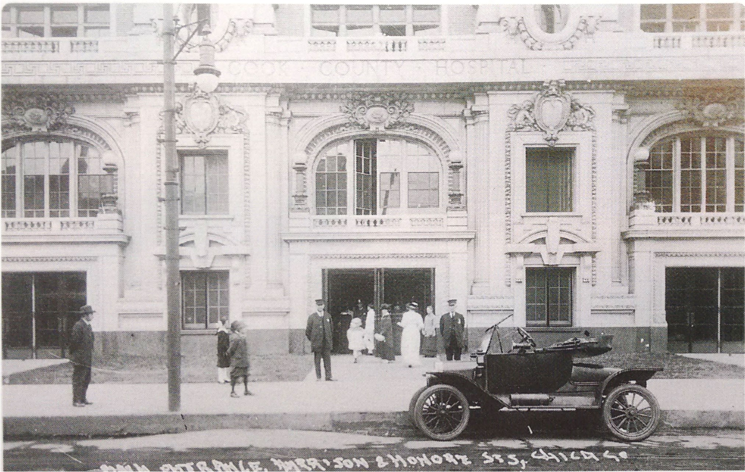
A historic photograph of the main entrance to the Cook County Hospital Administration Building soon after its opening in 1914 (from Chicago History Museum).

COMMISSION ON CHICAGO LANDMARKS
Rafael M. Leon, Chair
James M. Houlihan, Vice President
David L. Reifman, Secretary
Gabriel Ignacio Dziekiewicz
Juan Gabriel Moreno
Carmen Rossi
Mary Ann Smith
Richard Tolliver
Ernest C. Wong

The Commission is staffed by the:

Department of Planning and Development
Bureau of Zoning and Land Use
Planning, Historic Preserva on & Sustainability Bureau
City Hall, 121 N. LaSalle St., Room 1000
Chicago, Illinois 60602 312.744.3200 (TEL)
h p://www.cityofchicago.org/landmarks

Printed November 2018.

35

